­

Hands-On Lab

2D Game Development with Unity

VampKid vs the Zombie Apocalypse

Microsoft

Lab version: 1.0.0

Last updated: 7/13/2015

Adam Tuliper – Technical Evangelist, Microsoft

Contents

Overview 3

Game Architecture 4

Task 1 – Overview and opening the starter project 4

Task 2 – Setting up Visual Studio Tools for Unity (VSTU) 11

Task 3 – Importing and using artwork 13

Task 4 – Add the GameController to the scene 23

Task 5 – Adding the coins and level exit 25

Task 6 – Creating the HUD 31

Task 7 – Adding the zombies and player detection/elimination 40

Task 8 – Building for Windows 49

Summary 58

Overview

* 1. This lab introduces you to game development using Uinty, Windows 10 Developer tools and Visual Studio 2015. The game developed in the course of the lab wil be a Windows 10 Universal application. Windows 10 Universal apps can target the Universal Windows platform and can run on Windows desktop & tablets, Windows Phone, Xbox, and even Holo Lens.

# Objectives

* 1. At the end of this lab you will know:
  + How to use Unity to create a simple 2D game.
  + How to use resources (images, fonts, etc.) in your game.
  + How to add game logic.
  + How to use various inputs (keyboard, mouse, and touch) to control your game.

# Prerequisites

* 1. The following is required in order to complete this hands-on lab:
  + Unity 5.1 beta (available at the event and contains capability to build for UWP)
  + Microsoft Visual Studio 2015 RC or higher, and the Windows 10 Developer Tools
  + Visual Studio Tools for Unity (for Visual Studio 2015) – unityvs.com

# Tasks

* 1. This hands-on lab includes excercises built from the following tasks:
* Basic game project
* 2D animations
* Writing game logic to support player actions and AI responses
* Implementing additional screens and menus
* Supporting windows resizing
  1. Estimated time to complete this lab: 90-120 minutes.

### Game Architecture

* 1. This game implements the following screens:
  + Main menu - In the MainMenu.unityscene file
  + Level 1 - In the Level1.unity scene file
  + Level 2 - You will create this
  1. When launched, the first scene loaded will be the main menu. After the user choose the play button, a new scene Level1 will be loaded. When the objective is achieved (getting the key) then the final exit will show (which is the crypt)

The completed game will have a screen similar to Figure 1, depending on how you build your level(s) out.

* 1. 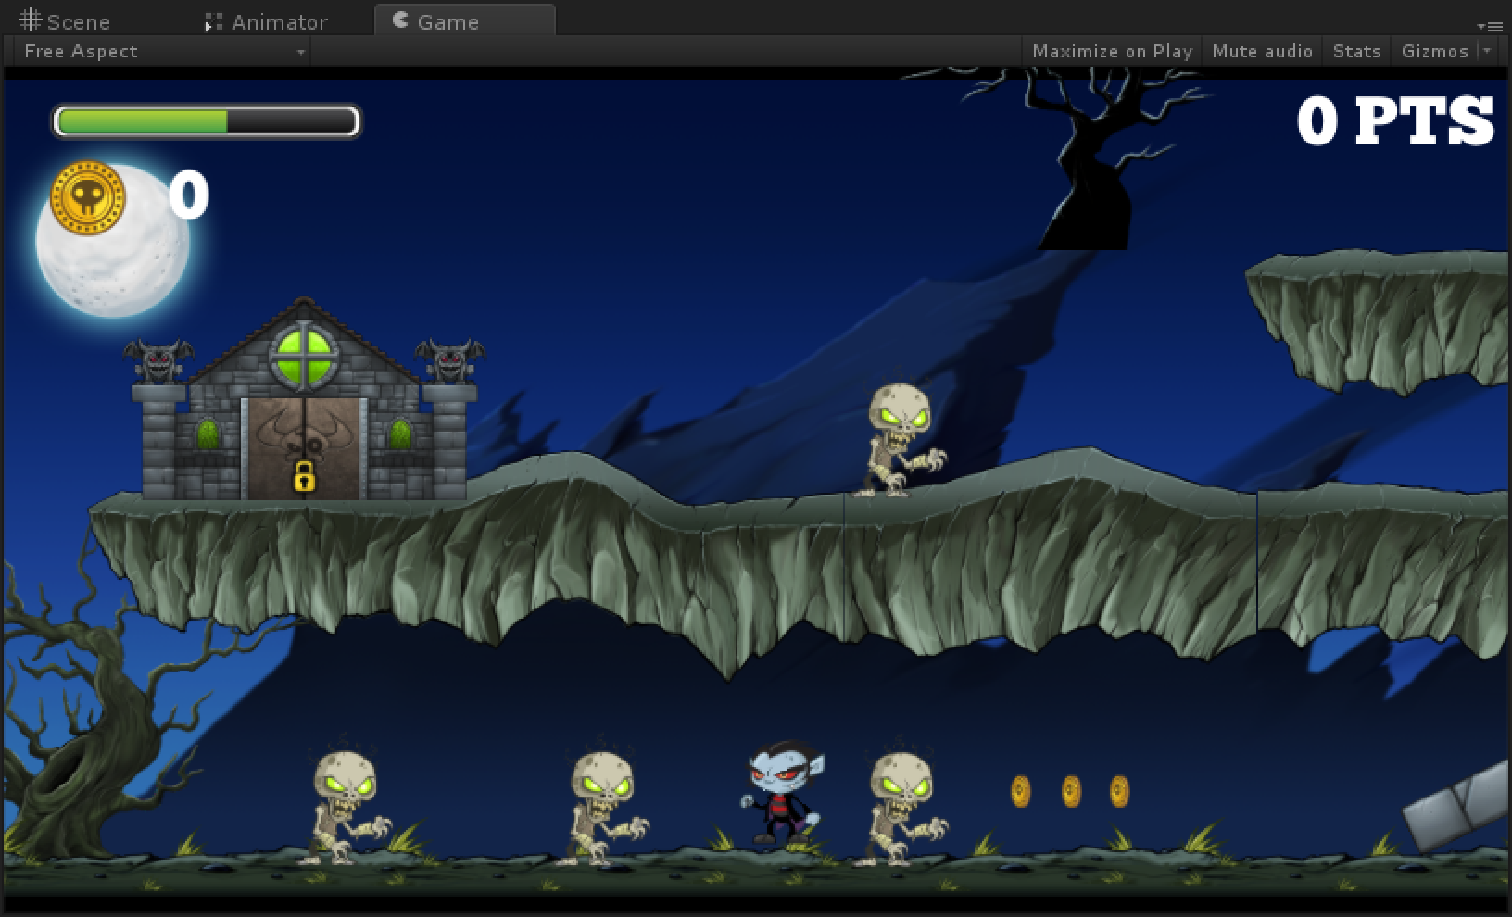
  2. Figure . Gameplay

### Task 1 – Overview and opening the starter project

* 1. Unity is an amazing integrated IDE, engine, and framework to develop both 2D and 3D games that utilize C# or UnityScript (JavaScript like syntax) for game code.

Our game, VampKid vs Zombie Apocalypse, is a single player game where the player controls a character and attempts to reach the end of the level. He must first retrieve a key that opens the crypt, which is the portal to the next level. Along the way are zombies that appear and try to ruin his day. This game is written in this lab as a single level game, but multiple levels are easy to add on as wil be discussed as the end. Thre are some accompying videos for tasks in this lab. Reading text is one thing, but at times its easiest to just watch a short video to see someone do a task. At near any point in this lab you can complete Task 8 and make a Windows Build. You don’t have to wait for the end, although it helps to run through the whole lab.

* NOTE - Before we begin, take a moment to find the Videos folder located on your file system in the starting project. There are several videos here so you can see how things are done. At times reading text may be more difficult than simply watching someone do a step. Where there is video content available for a step that needs it, it will be noted in that step.

1. Open Unity and click “Open Other” to open a project. 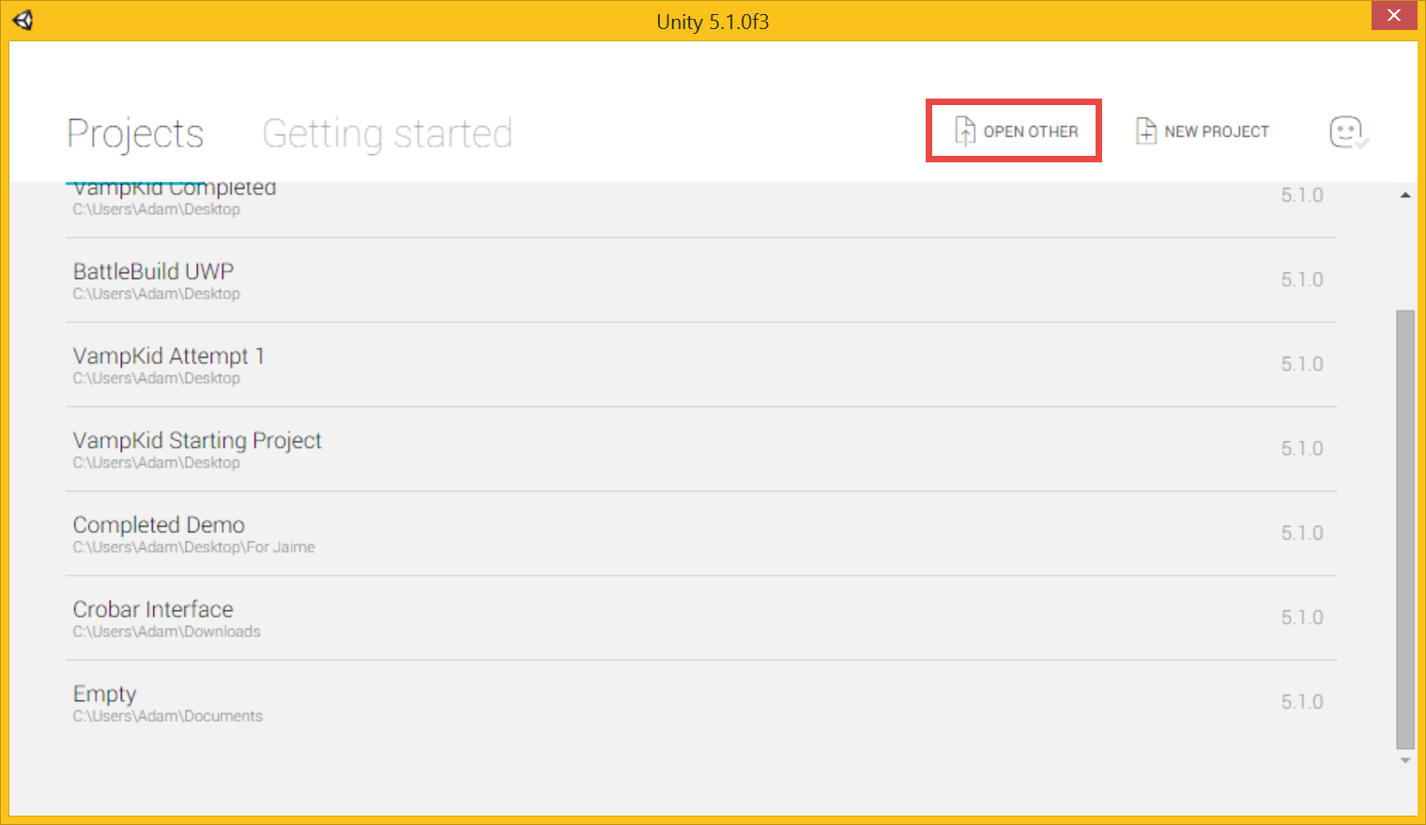
2. Navigate to the project folder “VampKid Starting Project” on the desktop and select the folder. With Unity, you open a folder, not a project file. 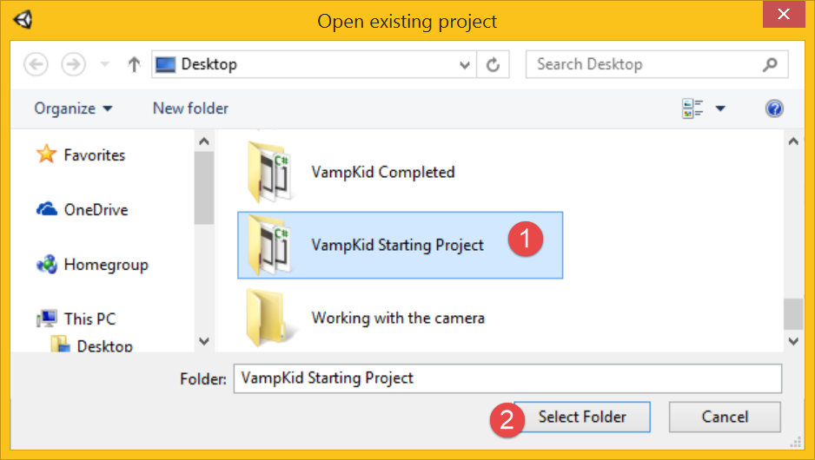

* NOTE - The correct folder to open for any Unity project has the Assets folder underneath it (don’t go into the Assets folder, select the folder above it). If Unity opens an earlier project, simply choose File->Open Project.

#### **What defines 2D vs 3D in Unity?**

Unity was always a 3D engine (and still is) but in version 4.3 they added support for 2D with built in tooling. You could do 2D previously but typically with third party toolkits or custom code. Selecting a project as 2D does several things. Assuming you are creating a new project in Unity (we are **not** doing that here, this is just for informative purposes)

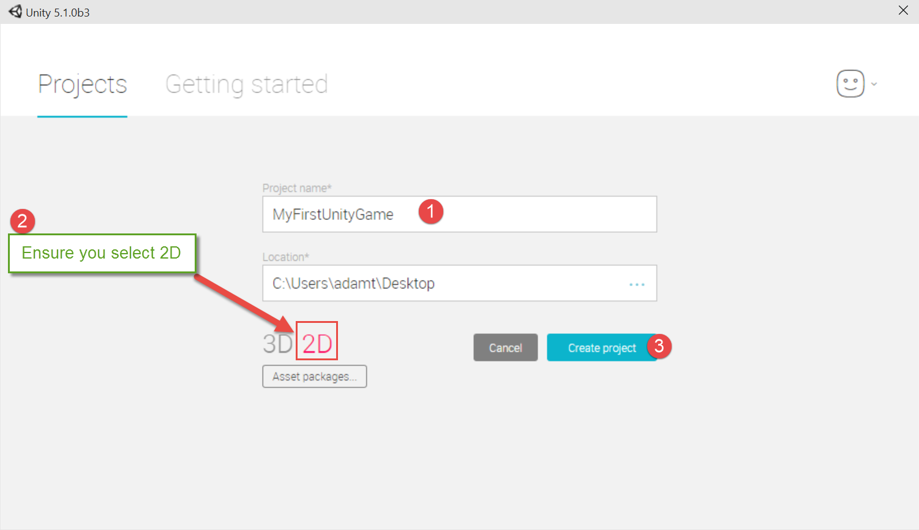

The settings Unity will default on a 2D project are as follows:

1. The 2D button (shown below) is defaulted in your scene view to lock your working area to two dimensions (X,Y). You can click this button at any time to go in and out of 2D, it’s simply a helper button while you are working in your scene view.
2. Importing art assets, like images, into your project sets them up by default as Textures with type Sprite. If this isn’t set this way, you cannot simply drag/drop images up into your scene as we will be doing.
3. Cameras are set to orthographic by default instead of perspective. Orthographic cameras see things as a fixed box out to infinity (no scaling or objects based on position) and not as we see things with our eyes, which is perspective mode. This effect is shown below

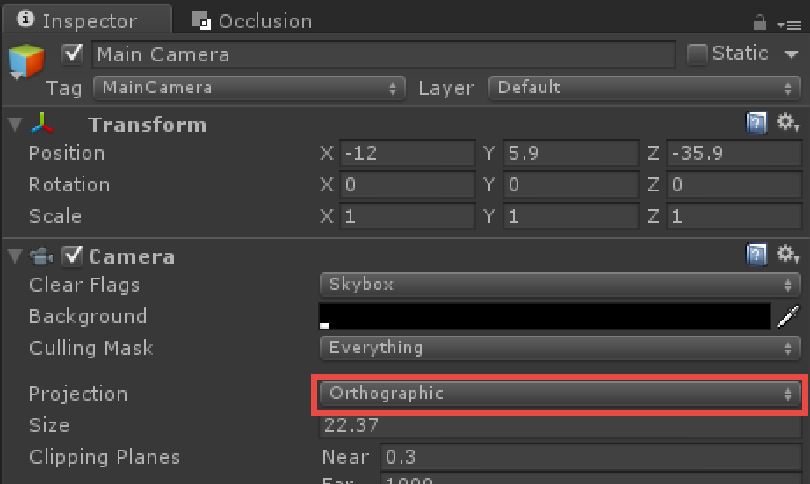

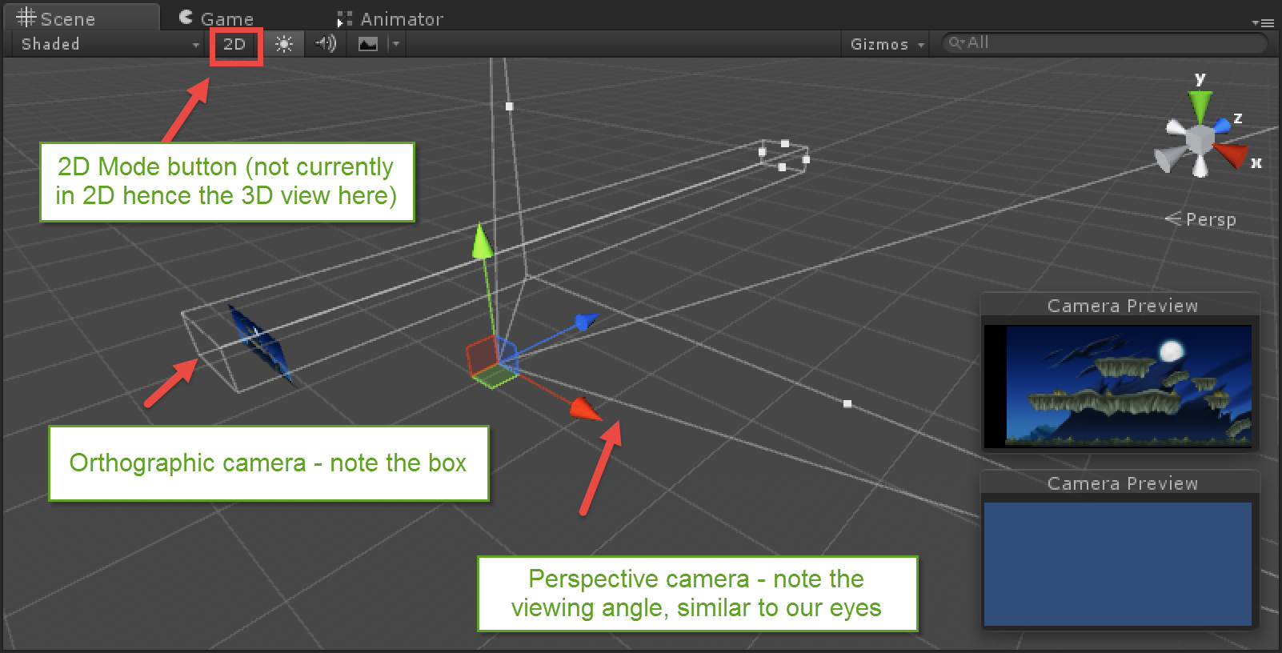

#### Unity Editor Basics

Unity games are composed of one or more scenes. Each scene must have a camera to see the world, and optionally contain code. It is possible to have a Unity game without any code, although functionality of course would be greatly limited. First, take a moment to explore Unity’s interface

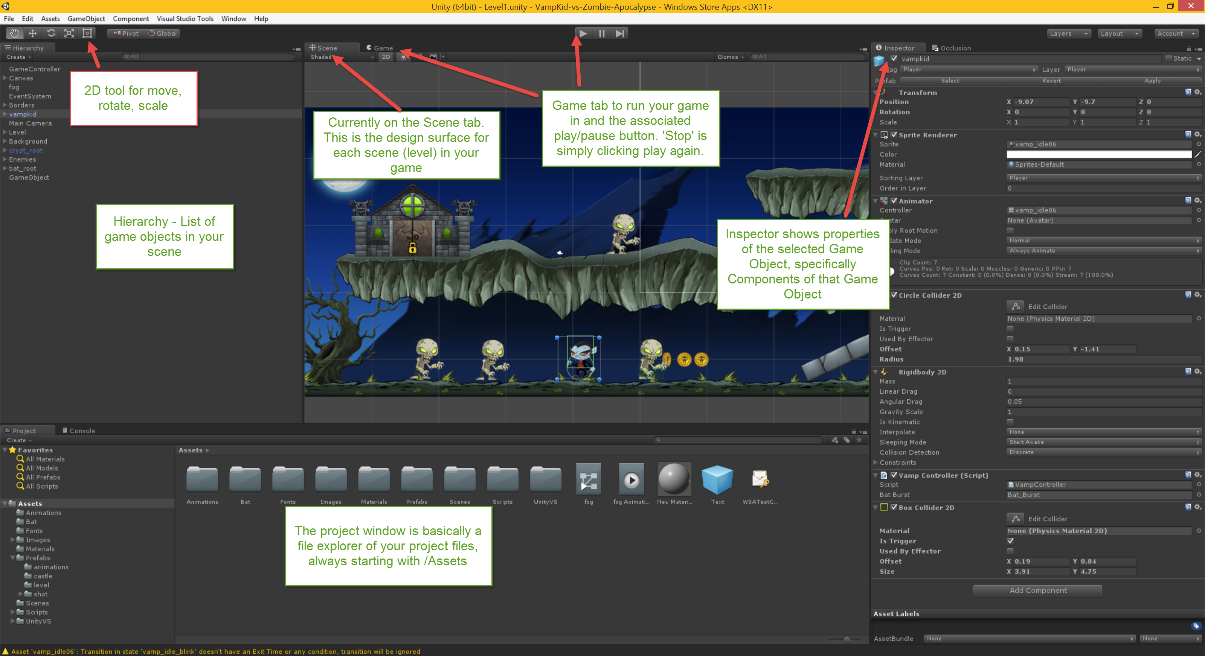

The Editor interface is easy to understand with a little use. There is your project explorer (Project tab), scene designer (Scene tab), a list of what is in your scene (Hierarchy tab), the properties of your highlighted object (Inspector tab), and the game tab and play button which work together to test out playing your game.

* NOTE - If at any time your windows pop out or you accidentally mess up the layout, simply choose this menu option to reset the windows (Windows->Layouts->Default). This will not harm anything and you can do this at any time. Try it now!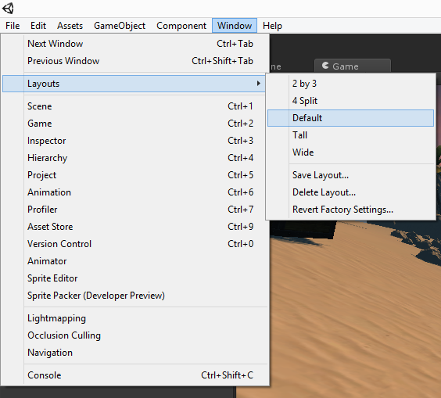

#### Exploring the project structure

You should have the following project structure in the project you have opened. This layout is personal choice ,you can rename any of these folders, move things around, etc. The only folder you can’t change is /Assets

|  |  |
| --- | --- |
| Bat – Contains a particle effect for when the player dies |  |
| Fonts – Contains a font that will be used for UI elements such as the score that is shown on the screen. Unity only has Arial built in by default. Any other fonts you’ll need to import into your project with .ttf or .otf files from sites like dafont.com. |
| Images – All of the artwork for this game is in this folder |
| Prefabs – Prefabricated units to drag/drop into scene. Some have been created for you and you will create some later as well |
| Scenes – A folder I like to use for scenes to organize them |
| Scripts – A folder to contain the main scripts you create in a game |

#### Exploring the sorting layers

1. Expand the layers dropdown on the top right and note the sorting layers that have been setup already in this project and the Player layer has been added. We’ll cover these shortly, but note that the sorting layers are for determining what images will get drawn on top of each other, similar to layers in any major image editing tool like gimp or photoshop.

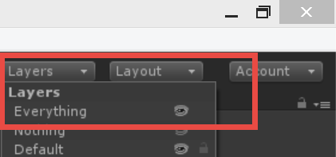

1. Note there are different types of layers. The Layers on top can be used for various things, in this game specifically we’re adding the main player to this layer so we can more efficiently have the zombies search for it when we talk about Raycasting. You can search for objects only on a particular layer for example.

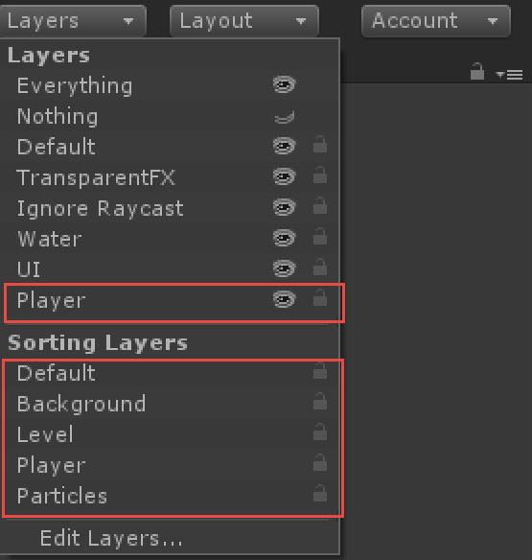

#### Playing your game

The Play button in Unity activates what is called **Play mode**. In play mode you are literally playing your game. This is a great shortcut as you don’t have to compile and export, simply click play and you are in your game running it inside of Unity’s virtual environment.

1. Click the play button in the toolbar. Notice that you switch to the Game tab from the Scene tab
2. Get out of play mode by clicking the play button again
3. Set your Editor environment to change color when you play your game by going to Edit/Preferences/Colors and altering the Play mode tint color by clicking in the color bar to choose a color. 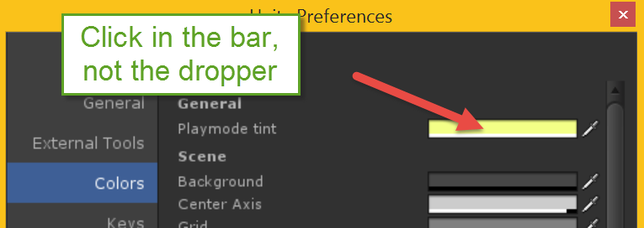
4. Go in and out of play mode again to see the effect of the color changes. If you are wondering why we would do such a thing, read the warning below ☺

* IMPORTANT: Here is an extreme word of caution though with play mode and I urge you to check it at every step. If the play button is highlighted, you are in play mode and any changes you make will be removed once you click play again to get out of play mode. In other words – play mode can be used to play your game and test our temporary changes. Once you exit play mode, those temp changes are lost. Be extremely careful in the steps below that you do not make changes while play mode is active.

In short: play mode looks like this (note the play button is highlighted)



And not being in play mode looks like this



Simply click the play button to move in and out of play mode. Try it now.

You can change your Editor’s color while in play mode via Edit->Preferences->Colors->Playmode tint. I highly recommend changing this color so you know when you are in play mode.

1. 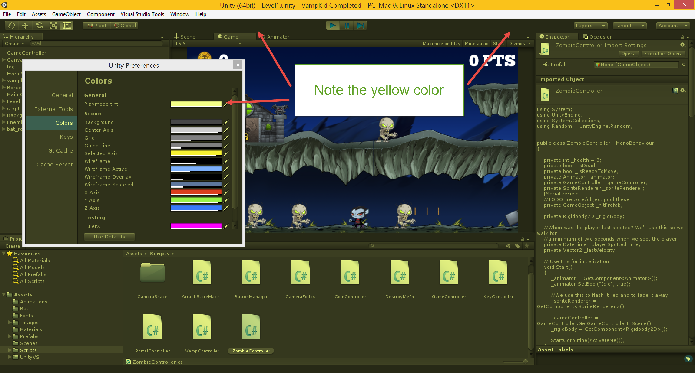

### Task 2 – Optional but recommended - Setting up Visual Studio Tools for Unity (VSTU)

The Visual Studio Tools for Unity allows you to develop and debug your C# code while writing your Unity game. Installing it is a two-step process. First install it on your system, secondly install it in to each new project you use.

This step is not necessary to write code in Unity since by default Unity will use MonoDevelop, however Visual Studio provides a significantly better coding environment and debugging capabilities.

1. If you are running this from a lab environment, VSTU should already be installed on the computer for you.
2. If you already have Visual Studio 2013 (any version but VS Express – note that community edition is free and works great!) or Visual Studio 2015 (any version) installed, you’ll want the Visual Studio Tools for Unity from [**https://www.visualstudio.com/features/unitytools-vs**](https://www.visualstudio.com/features/unitytools-vs)so you can use Visual Studio with Unity for an awesome dev/debugging experience.
3. If you don’t have Unity and/or Visual Studio installed note that Unity 5.2 includes the option to install Visual Studio during installation. Note that the Visual Studio download and install will take a bit and up to 9GB or so of space (we are working on trimming this down) but its well worth it. If you are sitting down to do the lab now, you can do this step at any point in your project or run the install in the background. It is optional, but highly recommended. Again I want to stress, you can still use Unity AS IS out of the box without Visual Studio (including completing this lab) but I highly recommend installing Visual Studio so you can use that as your code editor and debugger.
4. The older versions (before 5.2) you needed to bring in your Unity package for VSTU for each project you want to use VSTU with. From 5.2 onwards you don’t need to do this anymore. If you haven’t yet upgraded to 5.2 then navigate to Edit/Import Packge/Visual Studio 2015 Tools (or 2013) as shown below. Once this completes, your project is ready to go with VSTU.

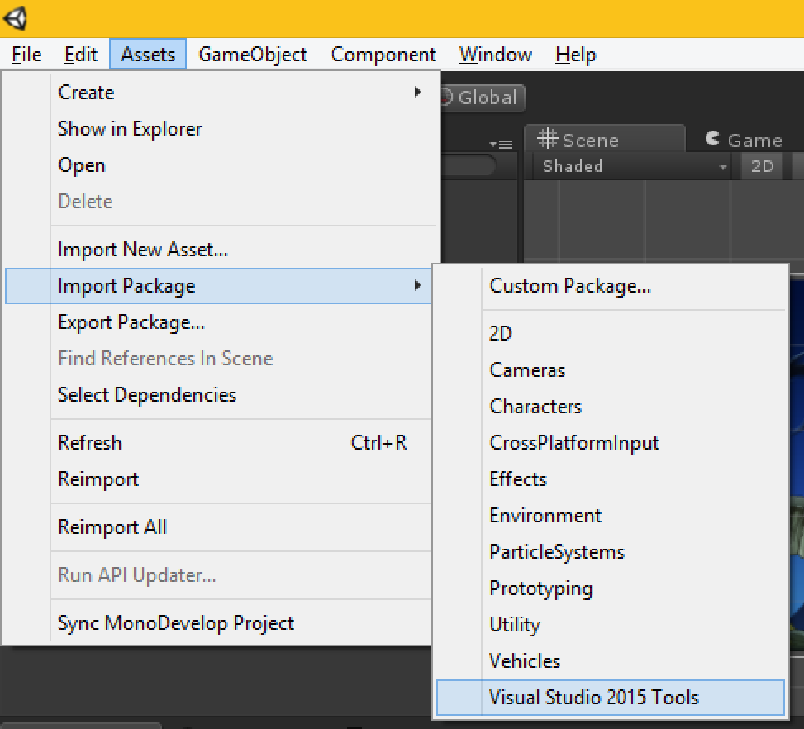

### Task 3 – Importing and using artwork

* 1. In this task, you will import a few images into your project that you will use to create your game. There’s been a bunch of artwork imported already and some turned into ‘prefabs’ for your use (don’t worry, we’ll cover prefabs soon)

1. Take the /Additional Artwork/coin folder from the starter project root folder (outside of Unity) and drag and drop it into your /Assets/Images folder. You can do this in Windows Explorer or take the coin folder and drag and drop it right into Unity’s project folder under /Assets/Images (see the /Videos/Creating the spinning coins.mp4 video to watch this in action)

TIP: Do not drag this folder from a zip file, this must be a file(s) previously extracted to a folder on your computer.

* NOTE: Your artwork will import as a particular type of texture called a Sprite. Sprites can simply be drag/dropped into your scene as we’ll do shortly. 3D projects won’t import images the same way (you can’t drag/drop an image into your scene by default in a 3D project, hence why we chose ‘2D’ when we created our project to set this up for you)
  + 1. 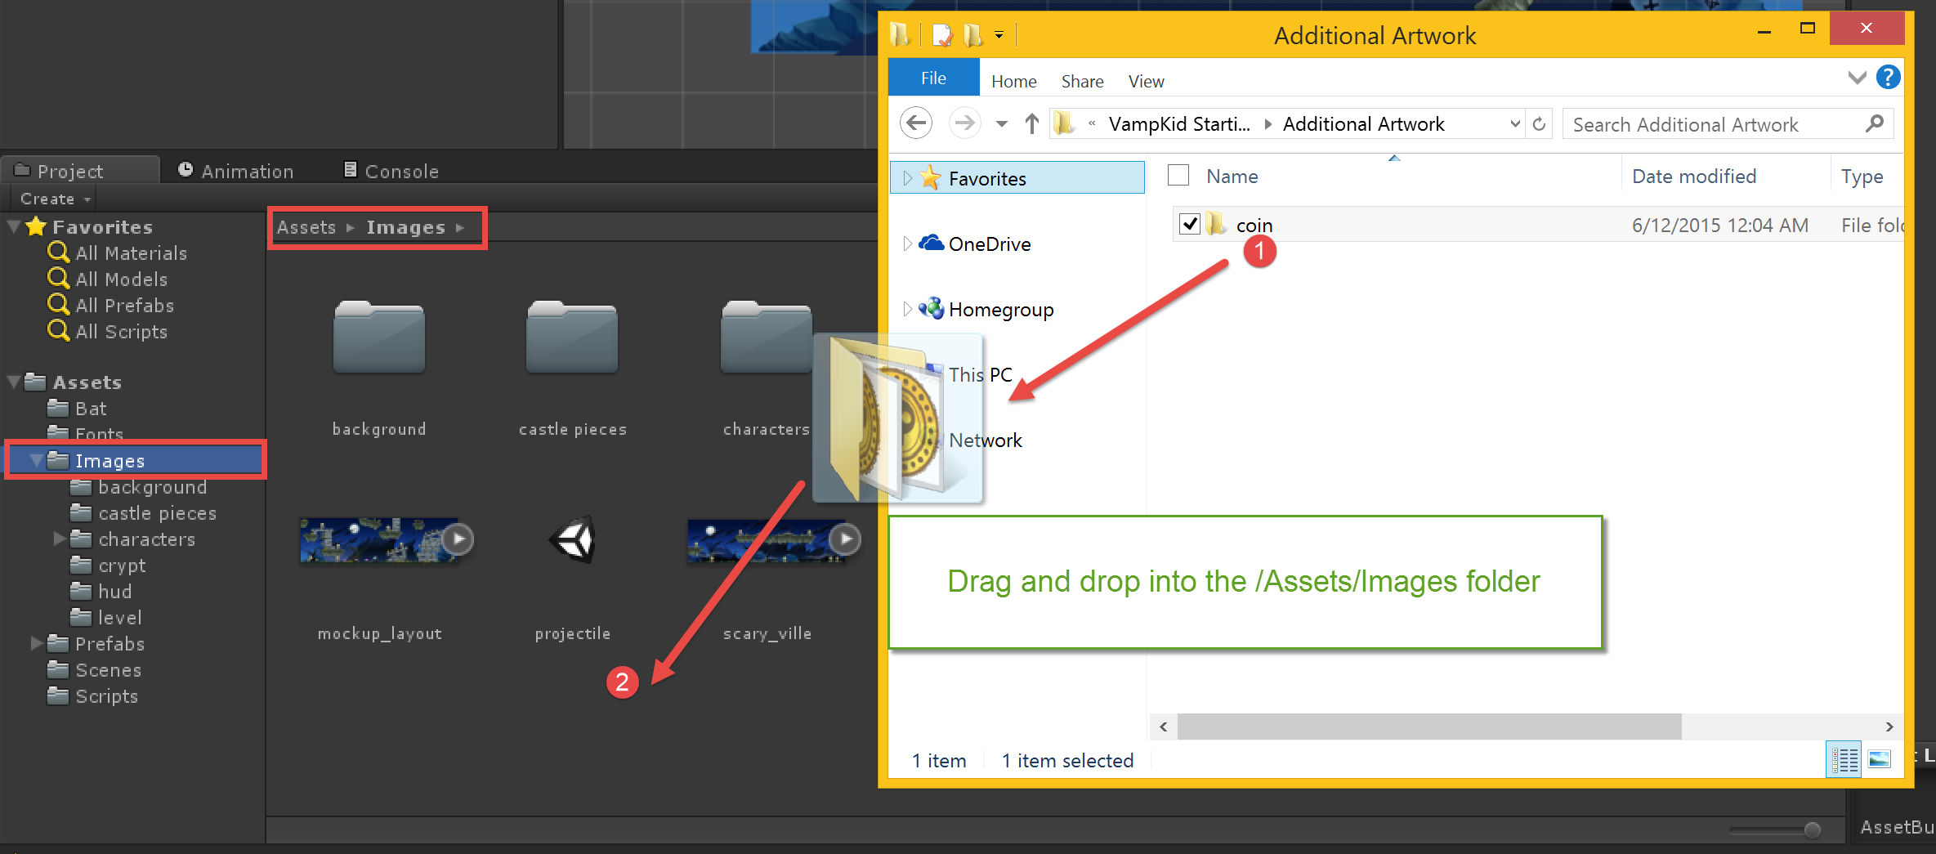

1. Open the scenes folder. A scene in Unity is your level. Your project has a default ‘Level1’ scene with a basic background. Double click on the /Scenes/Level1 scene file to open it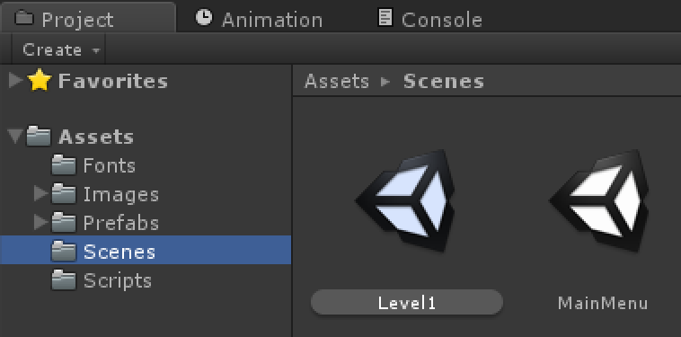

* BEGINNER TIP - Sometimes you will open your Unity project and see a default empty scene and it may leave you wondering what happened to your work. Simply navigate to your Scenes folder and then open your scene. Your work is not lost (provided you saved before exiting)

1. When the scene loads up, expand the item named “Background” (called a GameObject) on the left hand side (in the Hierarchy window) and then double click on it.

* TIP - When you double click on an item, it will bring it into focus. If you ever get lost, just double click on an item in the Hierarchy. This “Background”object was added to this project to simply act as a container to organize your background images (game objects) a bit more and place some other game objects within it.

1. Use your mouse wheel or track pad scroll to zoom in and out. Note that the background image is actually made of several higher resolution images. Unity will allow only a certain maximum resolution for images (2048), so these larger images allow higher resolution on bigger screens and will compress for mobile builds. Just a tip ☺

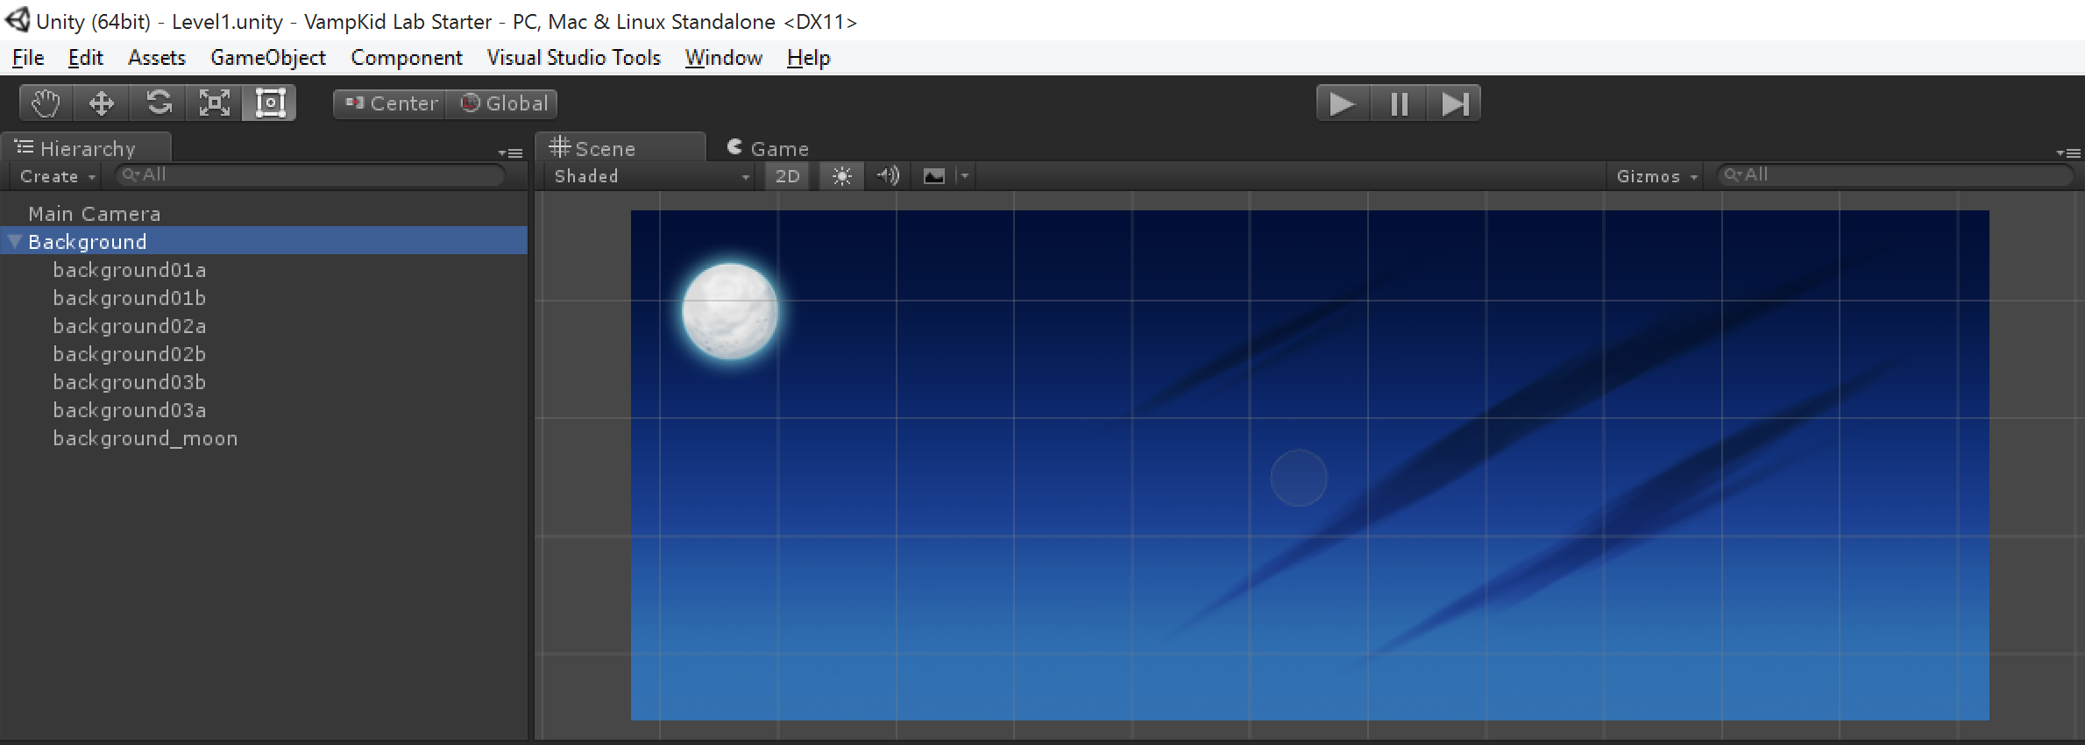

1. Expand the /Images/Background folder in the Project window. These are the various images you can drag into the scene view above to form your background. Drag in the /Images/background/background _mountains image from your project window up into your scene window (not your game view – ensure you are dragging into your scene window).

* NOTE – In the image below and possibly on your screen as well, there is a piece of the mountain seemingly missing. This may or may not happen in your scene view. Your background blue images and the mountains are occupying the same position in space and are both 2D images, so which image gets drawn out first or last? We cannot always be sure which one Unity would choose in this case, so we will fix that with sorting layers to be explicit about our drawing order.

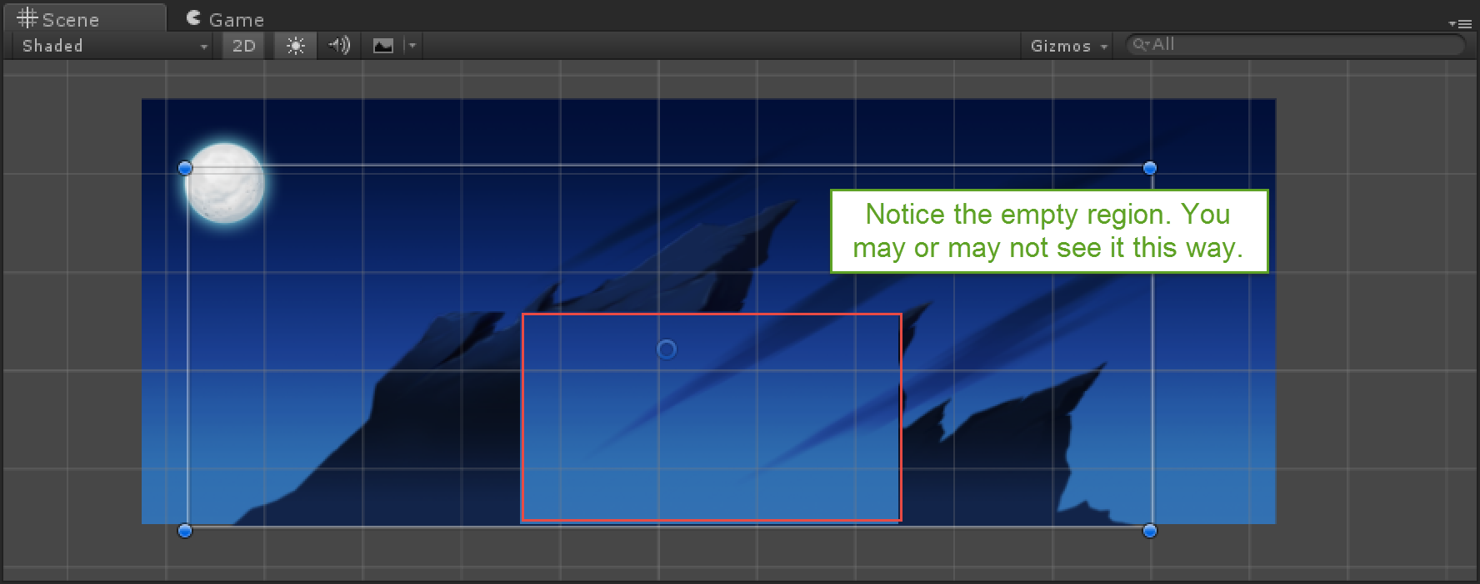

Let’s fix the sorting order for the images and organize the hierarchy window

1. First ensure you have selected your background_mountains game object from your hierarchy window on the left hand side.
2. Simply set a sorting layer for your image as background and set the Order in Layer to 1 as shown below

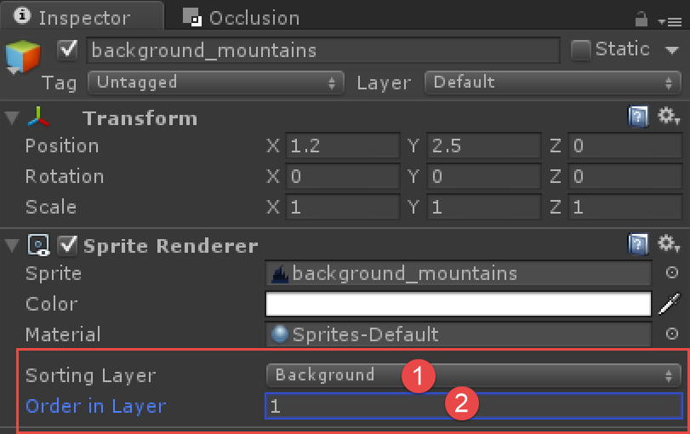

1. Lastly, as shown below, drag background_mountains (1) onto Background (2) to organize your scene view.

* NOTE - This process is called parenting and simply makes background_mountains a child of the Background game object.

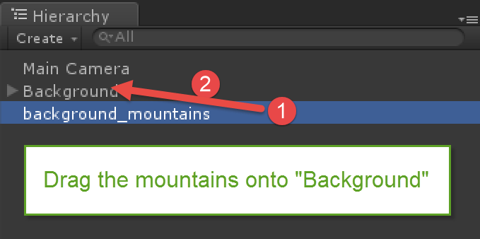

* + 1. Sorting Layers
    2. If you click Layers (1)->Edit Layers and then expand Sorting Layers you will see the following sorting layers (2) that have been setup in this project as shown below
    3. 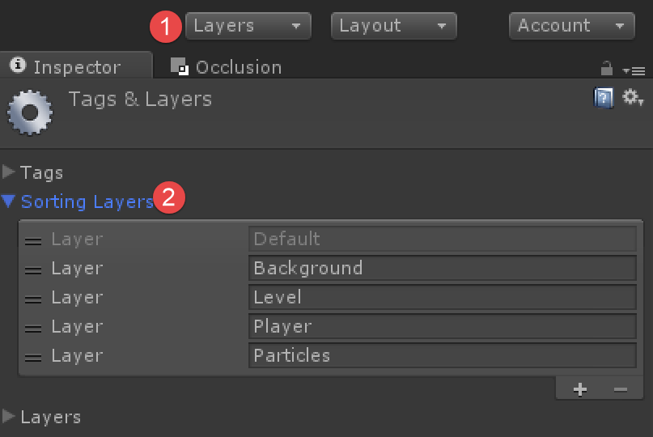
    4. Images (known as sprites) that are set on the Default sorting layer will be drawn out first. Those on the Background layer will be next, Level after that, and so on. The last Layer in the list (Particles) will be drawn to the screen last, IE on top of the other images. Within each sorting layer we can also define Order in Layer to fine tune drawing order for images on the same layer. I always specify the sorting layer for ***every single*** 2D sprite in my game. Not everyone does, but this helps prevent issues.

Changing the Order in Layer setting will cause objects within the *same layer* to draw out at different times.

Example

Background sky – Assume Layer=Background, Order in Layer = 0

* + 1. Background mtns – Assume Layer = Background, Order in Layer = 1
    2. In the above case, having the Order in Layer = 1 means it will be drawn after anything on the Background layer with an Order in Layer = 0
* NOTE: To navigate within your scene, use your track pad or mouse scroll wheel to zoom in/out of your scene. Right click rotates in 3D but in 2D will also allow you to click-move through your scene (pan). Clicking your mouse wheel and moving the mouse can also be used for pan. Also double clicking any item in your hierarchy brings it into view. Get used to navigating your scene. Don’t forget – control-z is undo, a faithful friend when you accidentally click and move something.

1. Ensure the last icon on the toolbar up top is selected; this is the ‘all in one’ 2D editing tool. This tool allows you to move, rotate, and scale out a 2D sprite.

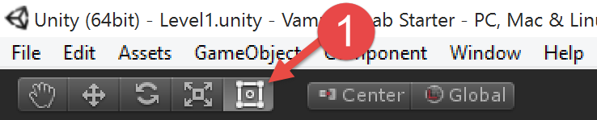

1. Experiment resizing some of the images for variety. In the image below note the resized highlighted clouds image. To do this, hold down shift as you click the grips on the clouds image to resize it and retain aspect ratio. Feel free to reposition the moon as well.

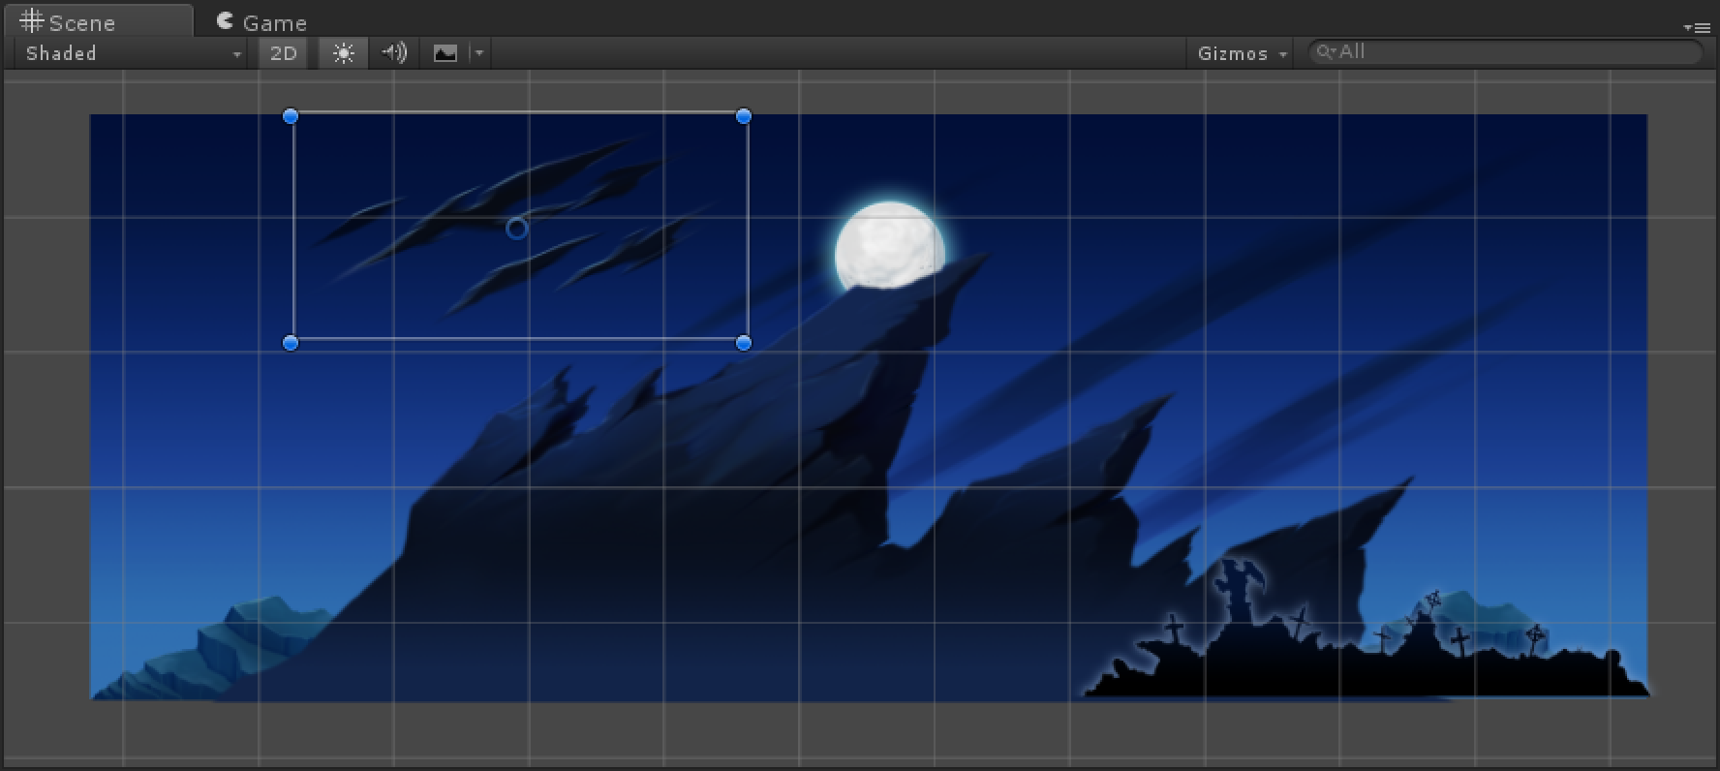

1. Change the Order in Layer for each sprite in the Background layer until you have everything in the correct order. After you change the Order in Layer, check the Game tab to see its final layout, just be sure to switch back to the Scene tab to continue your level design.

* CAUTION – A common beginner mistake is to try to drag objects into your Game tab. You cannot do this, items must be dragged into the Scene window.

1. Move the moon behind the mountains as shown above. You will need to make the moon’s Order in Layer at least 1 and the mountain’s Order in Layer at least one greater than the moon, ie 2 so the mountains appear in front of the moon. Remember that the higher the Order in Layer, the later it is drawn to the screen.

Next you will create more of the level.

1. In the Prefabs/Level folder you’ll find artwork you can drag and drop that already has the “Sorting Layer” set on it. Drag these items up into your scene from your project windows to build out levels.

* NOTE - The islands are meant to be used in order, ex large_platform01 aligns with large_platform02. There are also platform endcaps - large_platform02a goes on the left side of large_platform02 and large_platform02b goes on the right side of large_platform02. See “Creating and using prefabs” below for more details on these prefabs.

1. The bottom of the level should be created with the /Prefabs/level/base_ground_repeat prefab, as this is setup for the player to ‘land’ on.

* TIP - Use Vertex Snapping to position the images next to each other for the ones you want to ‘snap’ next to each other. This technique will snap the corner of one piece to the closest corner (vertex) of another piece. To do this hold down the V key, move the mouse inside the sprite you want to snap. Click inside the sprite NEAR but not on the edge. Move the mouse towards the destination sprite and it will snap into place. It is important to hold V first before you do anything. Then move the mouse and you will see the vertex get highlight. Ensure you do not click on the vertex (shown as a blue dot), but near it – still inside the sprite. It’s easier to watch than explain, check out the /Videos/Vertex Snapping.mp4video in the root HOL folder for an example of this.

1. Drag any one item into your scene, place it, and press control-d to duplicate it and move the new one into place. See ‘Vertex Snapping’ below for tips on aligning your art pieces next to each other.

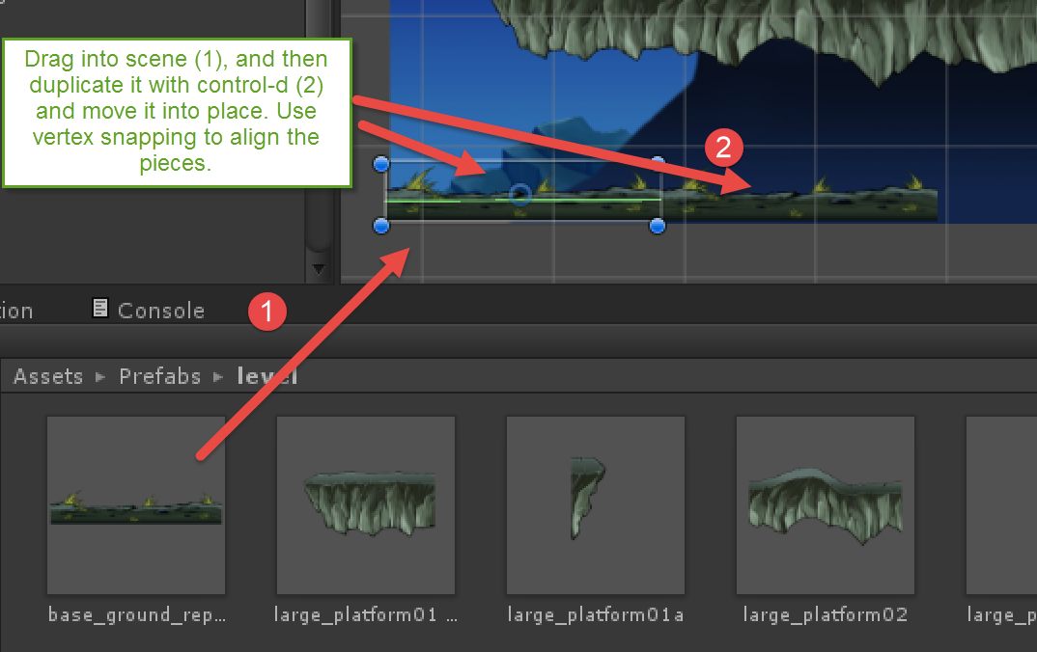

1. Variety is key! You can scale and rotate the various 2D items in your scene just ensure you have the 2D tool highlighted. The other icons/tools you can use as well for 2D objects – starting from the second one on the left are: Move, Rotate, Scale (ie resize) however as mentioned, that last tool is the ‘all in one’ tool which is typically the most used tool when working in 2D.

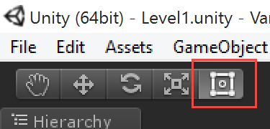

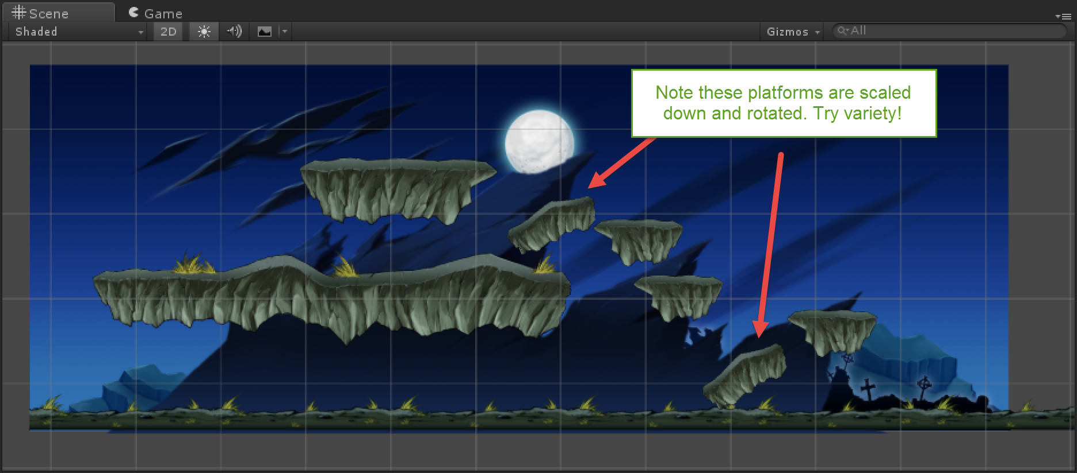

Creating and using prefabs

* 1. What’s a prefab? A prefab is a prefabricated unit – ie a pre made object. It is created by configuring an object in your scene, and then simply dragging it from the hierarchy into your project window.
  2. What’s the use?
  3. As we build out the level, it would be a bit difficult to set the sorting layer on every brick that we re-use. The advantage of a prefab here is we can turn that brick into a prefab by simply dragging it into our project folder fro the hierarchy (and it will then turn blue to let us know it’s a prefab) and now we can drag/drop that brick and retain all of its settings as we make many bricks. If we realize there is a problem on the brick, we simply update the prefab, and all of the other bricks are instantly updated.
  4. Note that all of the /Assets/Prefabs/Level items all have a Sorting Layer already set on them in their Sprite Renderer component as well as an Edge or Box Collider 2D component, which we’ll get to shortly.

1. The vampire character has been setup already with his animations and a controller (code) for him. Drag and drop the /Prefabs/vampkid prefab into the scene on top of the bottom ground.

* Make sure VampKid is above the ground, otherwise he will fall through it.This is a common beginner mistake
* **ADVANCED NOTE -** See the /Videos/Creating Vampkid.mp4 if you would like to create the vampire from scratch. You can always delete the vampire from your scene and then create your own from the video. For now just get the game up and running fast as it’s fairly common that you’ll download assets from the asset store already configured as prefabs to drag/drop into your scne.

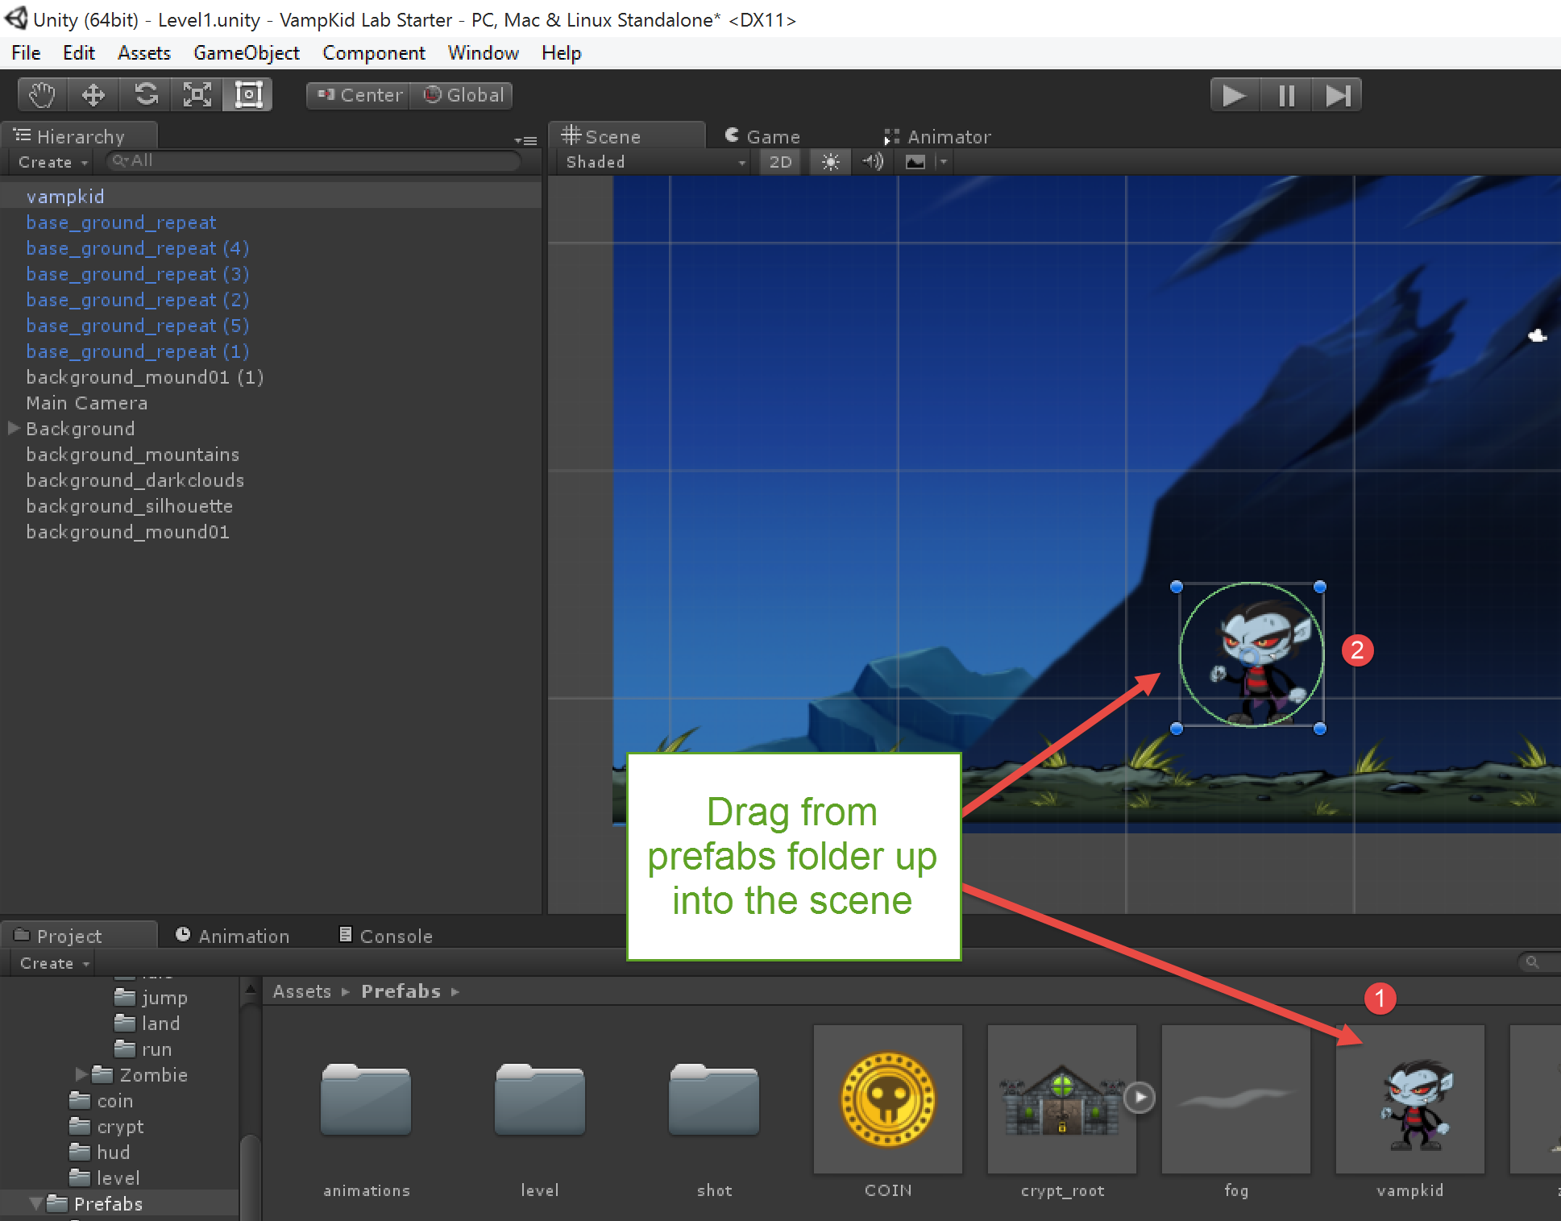

* + - * 1. Figure 4. Bringing the VampKid prefab into the scene

1. Our hierarchy is getting a bit messy. GameObjects can also be containers, so drag and drop the rest of your background items in your hierarchy window onto the Background game object in your hierarchy. Use the control key to select multiple items as you click them as shown in the image below

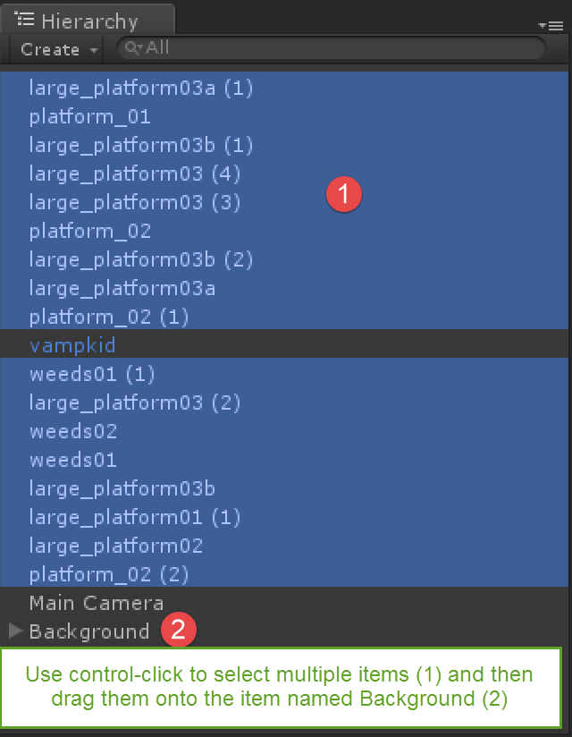 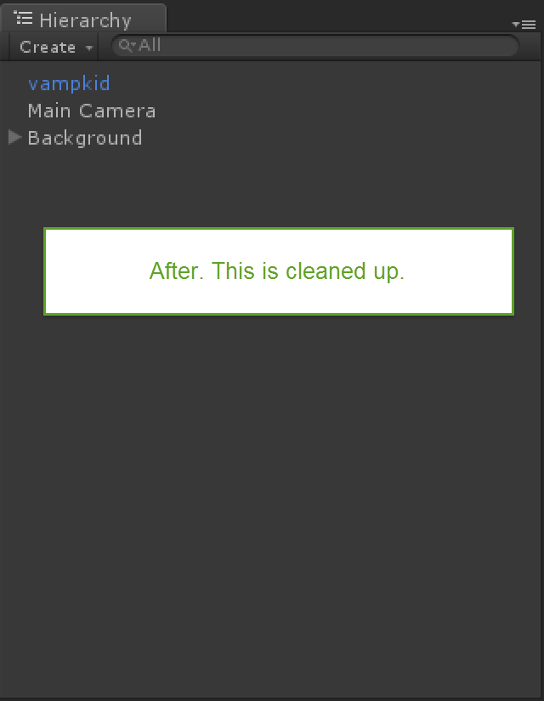

* + - * 1. Figure 5. Cleaning up the hierarchy

1. Save your work by pressing Control-s or use the File/Save menu.
2. Select the Play button on the toolbar. At this point you should be able to move left, right, jump using the arrow keys and the space bar (Figure 6). You can also shoot (not while running though, makes it a bit tougher ☺ ) by pressing your mouse button.

* WARNING – As mtnioned earlier, ensure you get out of play mode by pressing play again to deselect it or you can lose changes later. You should be back to the state shown here, ie not in play mode.



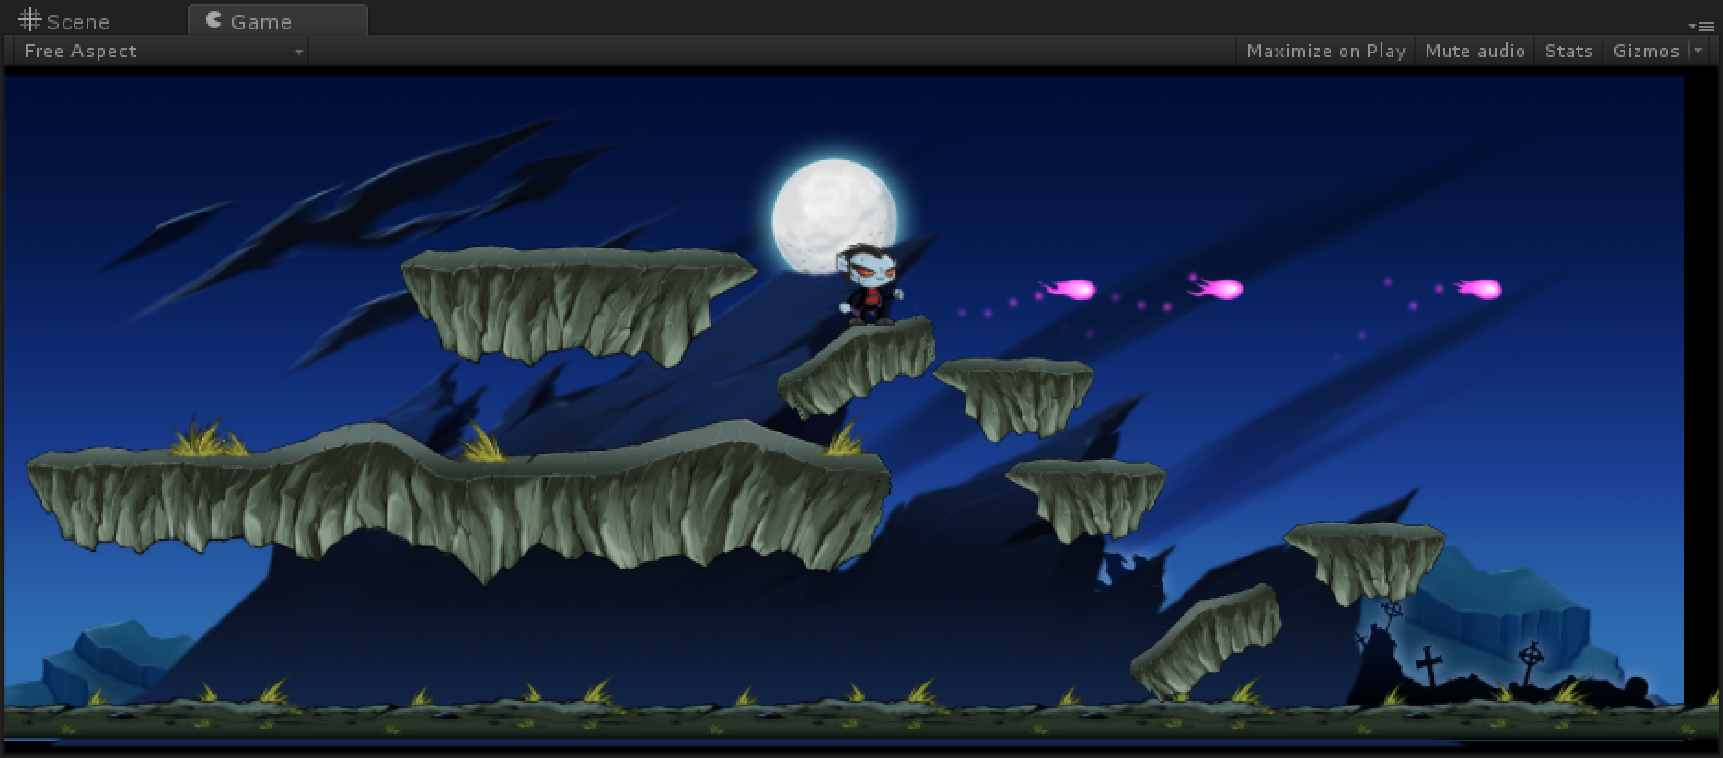

Figure 6. Playing your game

1. Select the Main Camera game object in the hierarchy.
2. Note that the camera size is not quite right. There is a bit of a black border on the top and bottom. Change the Size on the camera to 20.75 as shown in Figure 7.
3. You may also want to center the camera a bit more on your artwork by using the move tool on the toolbar (the second tool on the toolbar) and nudging the camera to the right. See the /Videos/Working with the camera.mp4 to see this performed

* NOTE - Unity supports two camera types, orthographic and perspective. Many 2D games use orthographic, which does not scale images with distance and does not distort objects based on viewing angle. If you set this to a particular value, regardless of target resolution you will see the same height as is visible in the Game window. Note that varying resolutions will have an effect on the width of your game, for the purposes of this starter HOL, keep the character placed starting closer to the center to avoid edge issues.

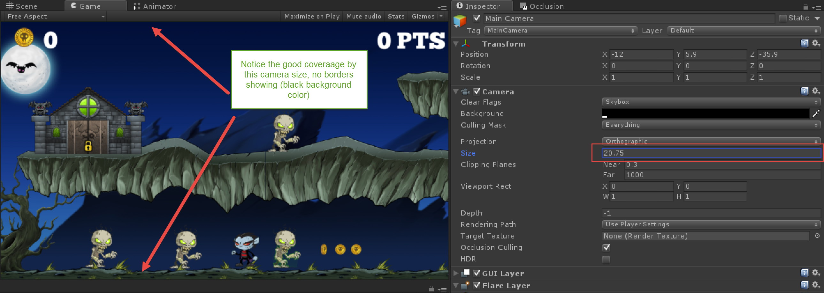

* + - * 1. Figure 7. Setting the camera size

### Task 4 – Add the GameController to the scene

It is common in games to have an object that acts as the overseer to the game and handles tasks like loading the next level, keeping score, and delegating other game tasks. This is typically called a game manager or game controller. We will get some errors in Unity’s console window when we run the game with this code – it will still run though. We will fix those later.

1. Choose GameObject/Create Empty

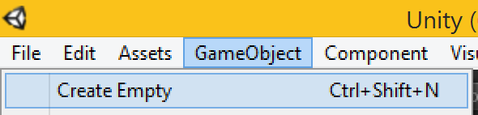

1. Select the new GameObject in the Hierarchy

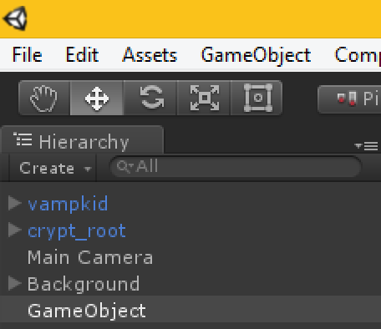

1. Rename this object to GameController (enter the new name in the Inspector window but ensure you press Enter after renaming it or your name change won’t be saved)
2. Set its tag to GameController as shown below. This tag will be used by other objects to find the GameController so they can then communicate with its script, which we’ll add next.

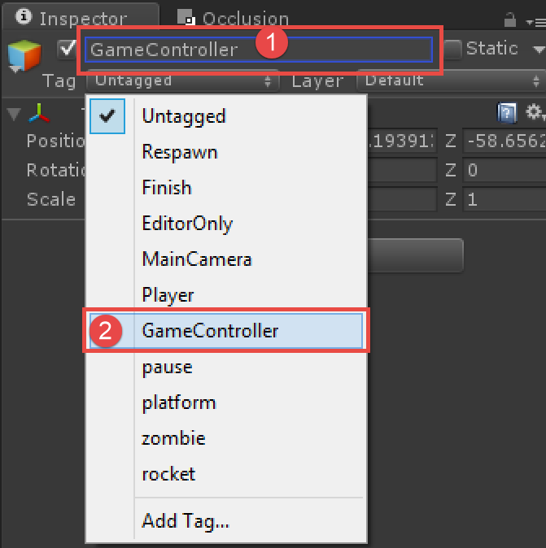

1. Assign the /Scripts/GameController.cs file to the new GameController object by dragging and dropping the script file onto the game object in the Hierarchy.

* NOTE - As an alternative you can also add a script to a a game object by clicking “Add Component” in the Inspector window for that Game Object and then type the name of the script as shown here

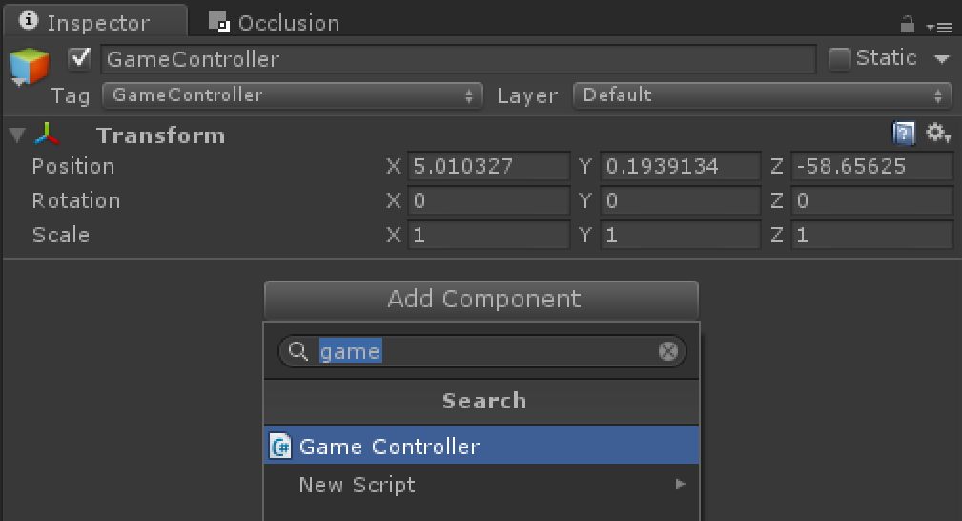

Code is added to the GameObject as a Script Component. The values that you see in the Inspector for a Script Component are nothing more than public variables from code.

1. Double click the /Scripts/GameController.cs file, as you will add code to keep track of how many coins we pick up and how many zombie points we get.

* NOTE – If you haven’t installed Visual Studio Tools for Unity in your project (but only installed it on your system) you will get an error when Visual Studio opens

Replace //private variables here with the following code. These will keep track of the points as well as give us a reference to the text boxes on the screen we’ll need to update

* + 1. C#

1. private int _coinScore;
2. private int _points;
3. //The textboxes on the screen we'll update
4. public Text PointsText;
5. public Text CoinScoreText;
6. public Text LevelMessageText;
7. public string LevelNameToLoad;
8. We will soon create those text boxes in our heads up display (HUD) as they don’t exist yet. Replace //Increment scores here in /Scripts/GameController.cs with the following code to increment the scores and update screen text
   * 1. C#
9. public void IncrementCoinScore(int amount)
10. {
11. _coinScore += amount;
12. if(CoinScoreText) CoinScoreText.text = _coinScore.ToString();
13. }
14. public void IncrementPoints(int amount)
15. {
16. _points += amount;
17. if(PointsText) PointsText.text = _points.ToString() + " PTS";
18. }

## 

### Task 5 – Adding the coins and level exit

* 1. Next we will add in the zombies, coins we can pick up, and the end of the level. As part of the game play, we cannot activate the level exit until we have found the key and picked it up.

1. Bring the portal into the game so we have an area to exit the level. Open the /Prefabs folder in your project window and drag the crypt_root prefab into your scene in a place that the player can get to it. If you want to build the crypt yourself, see /Videos/Creating the crypt.mp4

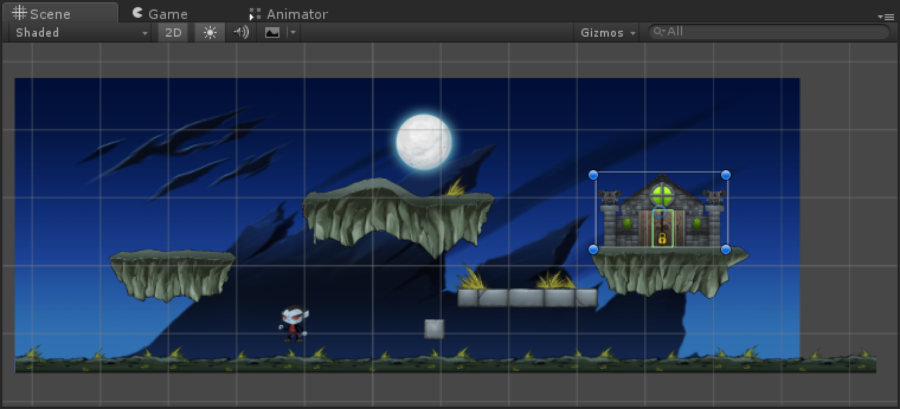

1. Select the crypt_root prefab (the portal) and in the hierarchy window, expand it. The crypt_root has a child game object named crypt that has a script on it the GameController needs to know about so it can “activate the portal” when the user collects the key in the scene. We need the crypt_root game object expanded like is shown for the next step

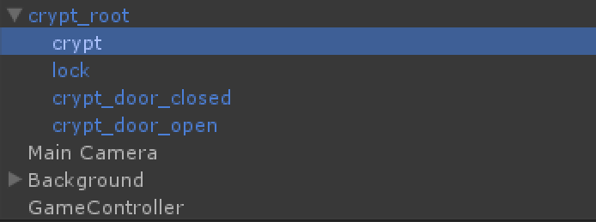

1. Next select the GameController in the hierarchy. In the Inspector window, notice the missing “Portal Controller from crypt” variable as shown below. Drag and drop the crypt game object from step 2 above onto this variable. This will set the reference in the game controller to the crypt’s PortalController script component and enable it to call methods within it. You could also click the circle button next to “None (Portal Controller)” and select crypt there as well, that will filter out and only show you game objects that have a PortalController script component on them. Alternatively you can select the circle selector as pointed to in the image below and select the resulting crypt game object.

* TIP – You will need to click and drag the crypt game object all in one motion. If you click it first, it will highlight it and clear out the selected GameController properties.

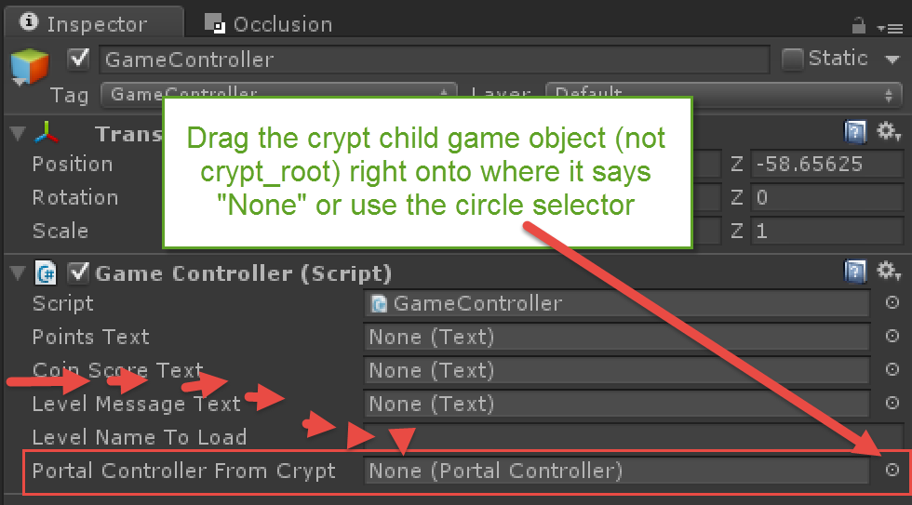

Let’s create a spinning coin we can pickup

1. In the /Images/coin folder (this artwork you imported in a prior step) select all the coin images by using control-a on the keyboard.
2. Drag all of those selected images into the scene view as shown in **Figure 7** below. Unity will create an object named similar to coin0X (coin01 for ex) in the hierarchy. The coin image won’t be visible since it is on the Default sorting layer behind everything, so click on coin0X and set the Sorting Layer = Level in the inspector.

* NOTE - A word on animations in Unity. When you take multiple images and drag them into the scene, Unity will create an animation from them, which will flip through the various images at runtime to create an animation. An animation is made of two things - an animation controller that exists on the game object that will be animated, and secondly an animation file with the .ani file extension. This is a free standing file (not assigned to a game object directly) which contains animation data with keyframes. Keyframes simply tell Unity “at some point in time, set some value on a game object’s component(s)”. In the case of 2D animations, this animation data tells a game object to swap the image out in its Sprite Renderer component multiple times a second. See the /Videos/Creating the coins.mp4 video to see this process done.

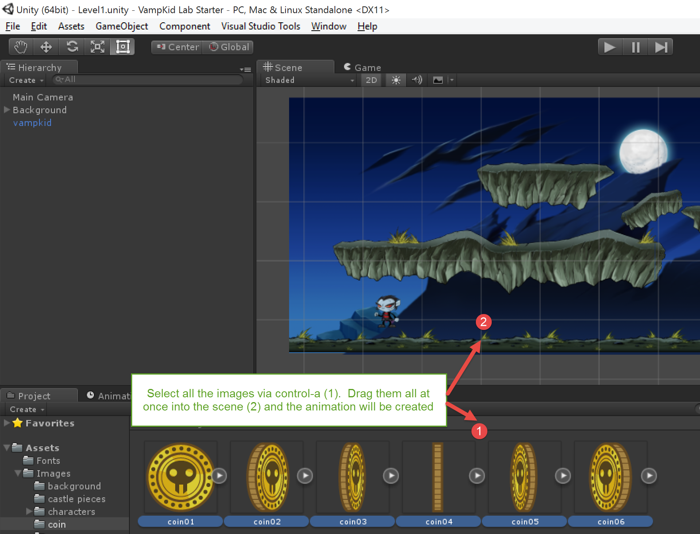

**Figure 7 – Dragging coins into the scene to create an animation**

1. Create a new C# script in the /Scripts folder named CoinPickup (this is case sensitive and it _must not_ contain any spaces in the name). You can right click in the /Scripts folder and select Create -> C# Script. Double click on the file to open it and replace the entire contents of the file (press control-a to select all the code in the file and then press delete) with the following code:
   * 1. C#
2. using UnityEngine;
3. using System.Collections;
4. public class CoinPickup : MonoBehaviour
5. {
6. private GameController _gameController;
7. // Use this for initialization
8. void Start()
9. {
10. //Find the GameController
11. _gameController = GameController.GetGameControllerInScene();
12. }
13. void OnTriggerEnter2D(Collider2D collision)
14. {
15. if (collision.gameObject.tag == "Player")
16. {
17. if(_gameController) _gameController.IncrementCoinScore(10);
18. Destroy(gameObject);
19. }
20. }
21. }

* NOTE – Code files in Unity have a naming convention that must be followed. The file name must match the class name Ex. If the file is named CoinPickup.cs, then inside the code file it must be named specifically public class CoinPickup : MonoBehaviour

1. To assign this new code to the coin, ensure your coin0X game object is selected and then click “Add Component” in the bottom of the Inspector window. Type “pickup”, select the resulting CoinPickup script as shown below. Alternatively, you can drag/drop CoinPickup.cs onto the coin0x game object in the Hierarchy.

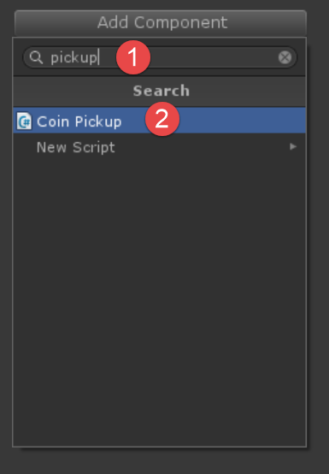

1. Click “Add Component” again and navigate to Physics 2D and then select Box Collider 2D (or you can type Box Collider 2D when you click Add Component).

* Ensure you select Box Collider **2D** and not just Box Collider, as that is meant for 3D objects

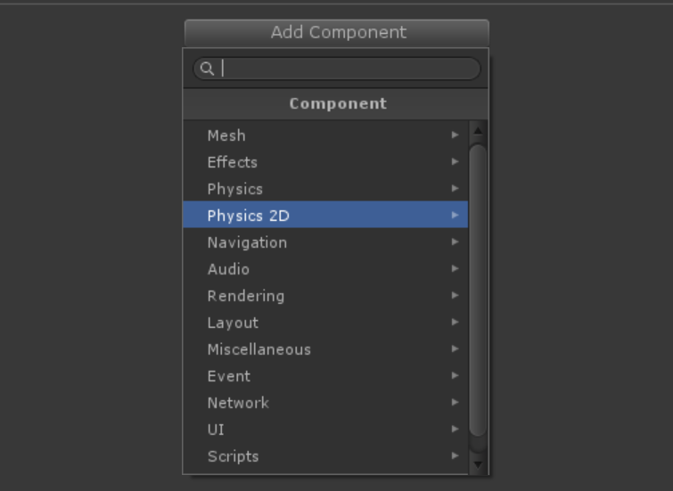

* NOTE - If you add the **wrong component** you can always click the gear in the upper right hand corner as shown below and select Remove Component.

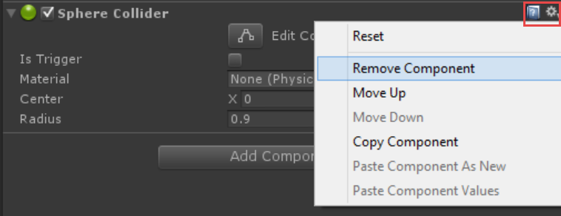

1. Check off Is Trigger on the Box Collider 2D. We want to be able to detect when the player comes within range of this item, but not stop the player. 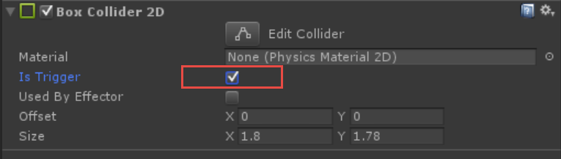
2. Save your changes by pressing control-s and then play the game. You should now have a spinning coin.
3. Ensure you are not in play mode
4. We now have a working coin, go ahead and create a prefab from it by dragging the coin game object from the Hierarchy into the /Prefabs folder. It will turn blue once you do this to indicate it is now a prefab. Once it is there in your /Prefabs folder, you can drag and drop it into any scene in your project and reuse it.

* If you need to change the coin in the future simply chage the /Prefabs/coin.prefab and all the rest of the shared instances across your scenes will get the new settings since they all are instances of that prefab.

1. If the coin is too small, **DO NOT SCALE IT** in the inspector. There is a much easier way and more consistent way. First highlight just the coin images in the project view using control-click to select each one.

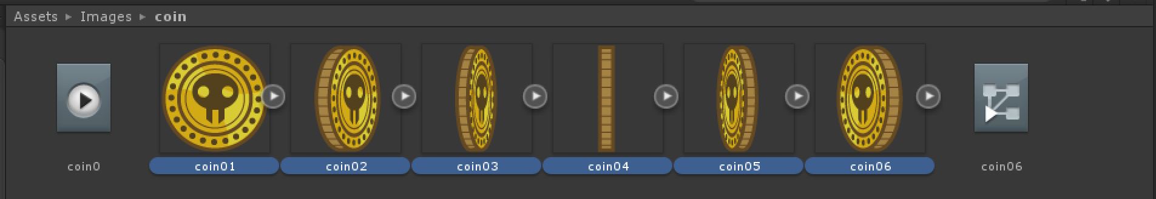

1. Next make the Pixels Per Unit value smaller as shown below. The fewer pixels per unit, the larger the image will be. The default is 100, which means a 100x100 image in Unity will be one meter. Typically you don’t need to know that is a meter, but just knowing that making the Pixels Per Unit value smaller will make your images bigger.

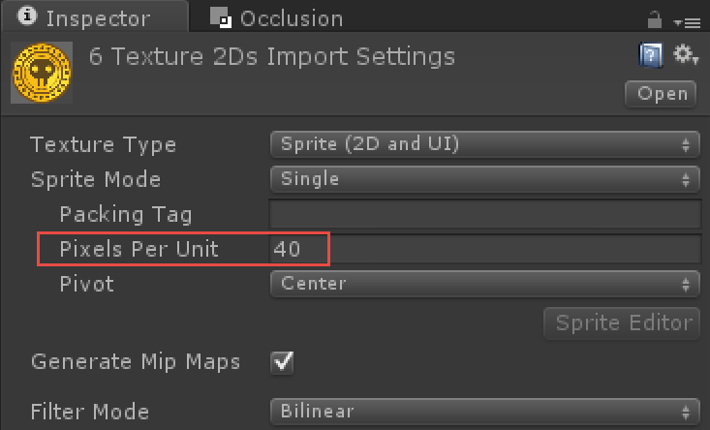

### Task 6 – Creating the HUD

In this task, we will create the user interface to the game. This is comprised of a zombie kill score, a coin collection score, and a general information text overlay we can display messages such as ‘You died, restarting….’

Everything done in Task 5 is viewable in the 7 minute video **/Videos/Setting up UI elements and GameController references.mp4**

Create the “Level message” textbox to the screen we’ll display informational messages in to the user

1. Create a text game object by selecting the GameObject->UI->Text menu.
2. Rename the new object to HelperText and uncheck to mark it inactive. This checkbox is to the left of the name as shown below
3. Set the height to 59 by typing in those values for the height as shownbelow
4. Ensure the textbox is selected to fill the width of the screen. You can click on the grid, shown highlighted below as (1), and then hold click on (4) below while holding shift & alt.

* NOTE - This will center the item and cause it to stretch to fill the screen. This will not resize the font, that is done later with out canvas scaler component, but this just allow our text to fill up a wider area on wider screen devices and ensure it is centered properly

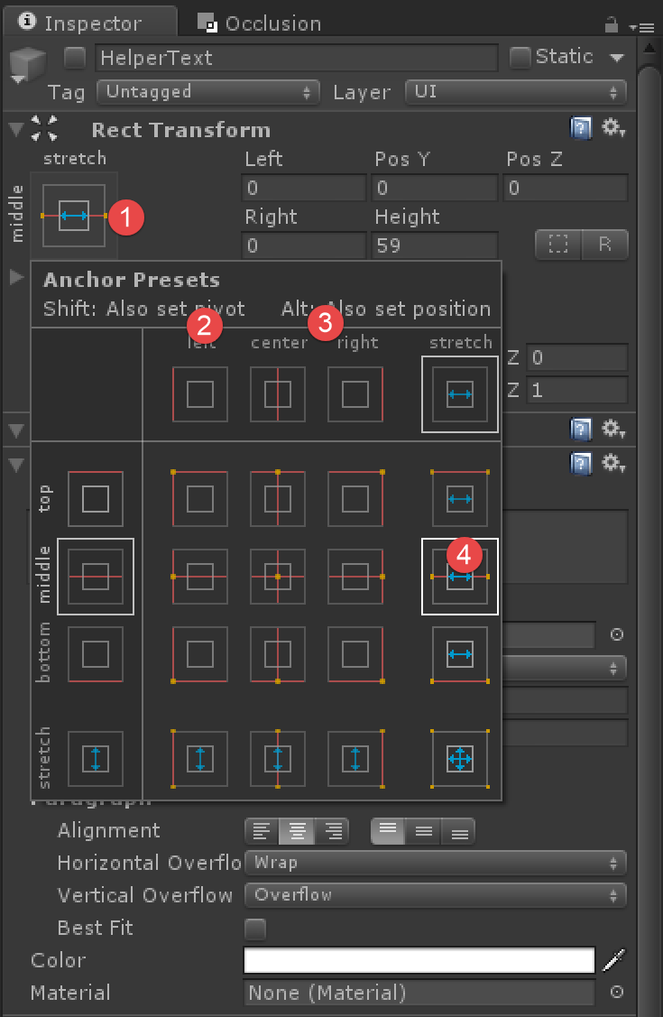

1. Center the text (using the button in the Alignment section as shown below in fig 11), use **font size 41**, and select the Chunkfive font (click the circle next to the font – that’s the selector – this font is already in the starter project) in the /Fonts folder.
2. Set the **Horizontal** overflow = Wrap and the **Vertical** overflow = Overflow. This will help ensure the text doesn’t get cut off when long messages are displayed.
3. The project has this font file already added to it, you can simply download more fonts if you’d like from sites like <http://dafont.com> and drag/drop the .otf or .ttf font file into the Project window (ideally in the /Fonts folder) to make them available in your project. Select the ChunkFive font as shown below by clicking the circle selector button next to the Font setting and choosing ChunnkFive

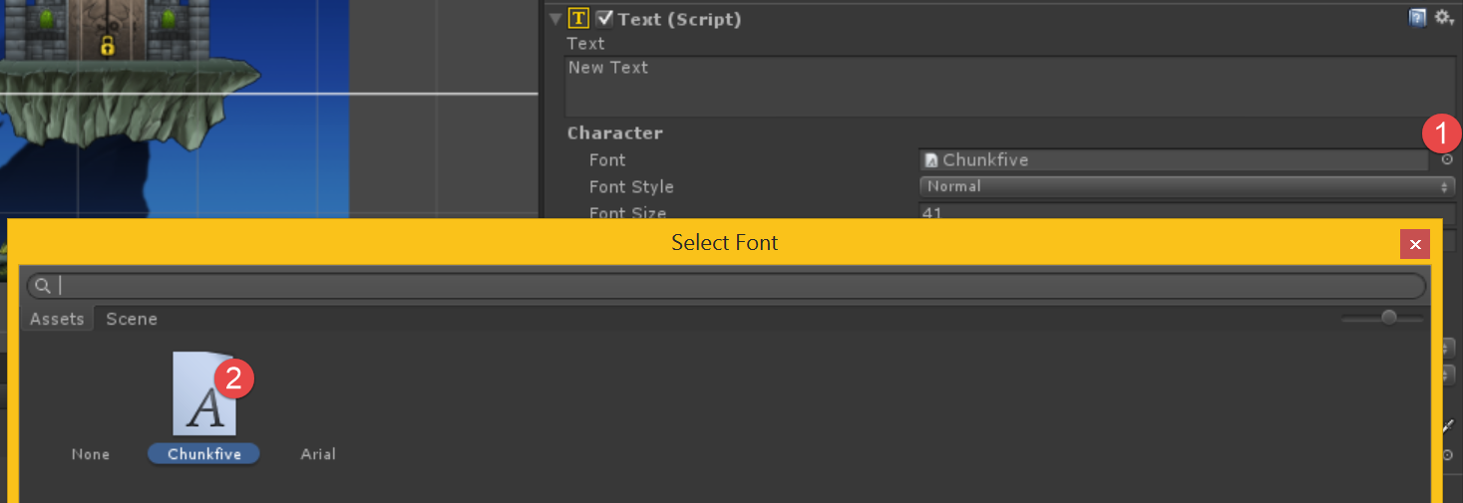

1. Double check that all of your settings match those shown in **Figure 11**

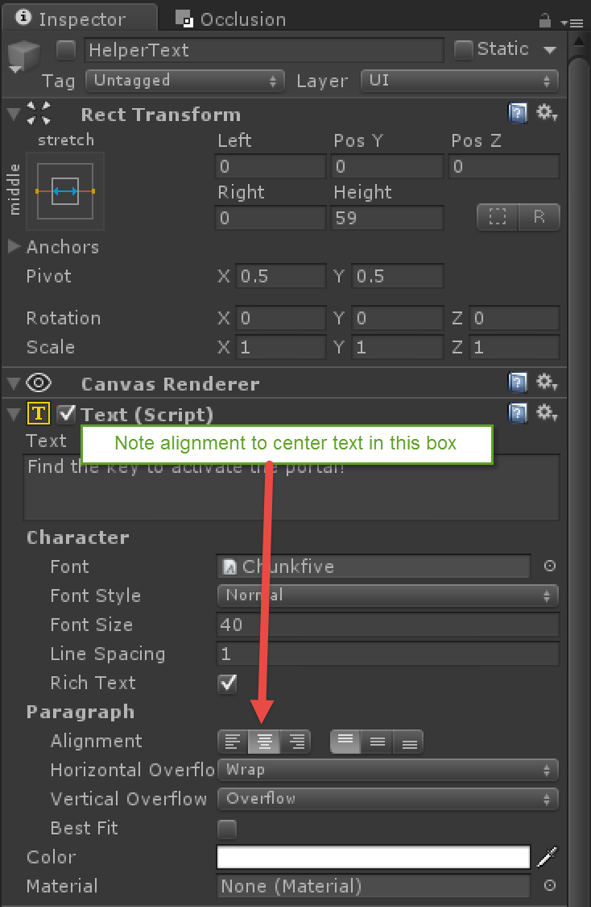

**Figure 11 Settings the text alignment and other properties**

Create another textbox to go in the upper right hand corner for zombie kill points

1. Select the GameObject/UI/Text menu to create a new textbox
2. Rename it to Points
3. Dock it to the top right by clicking the anchor grid as shown below, then holding shift-alt and the top right corner

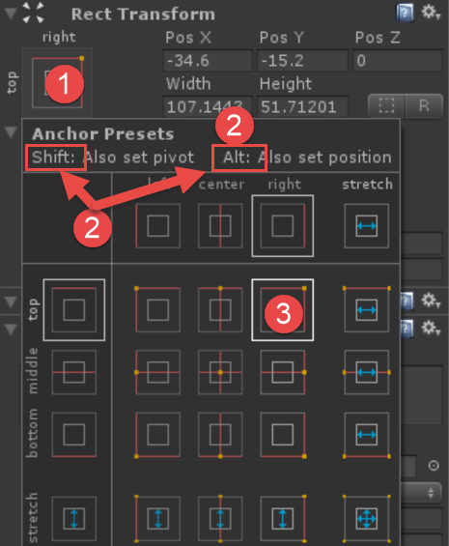

1. Set the values as follows for #1-4 as shown below (0 PTS, ChunkFive, 37, and white). To change the font color to white, click where the **#4** shows below - right in the middle of the color strip and you can select a new color. Do not select the dropper icon to the right, that is for sampling a color on the screen.

* Note - You likely won’t be able to see the font show up as the box will be too small. We’ll resize it in the next step

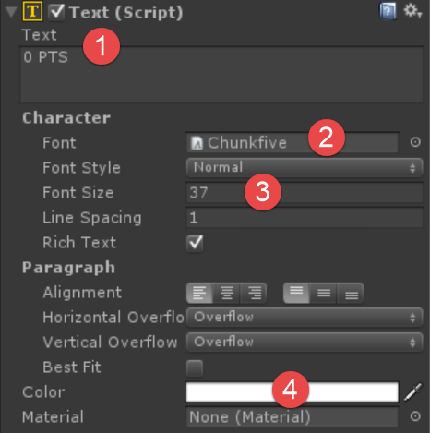

1. Ensure the Score game object is highlighted by double clicking on it in the inspector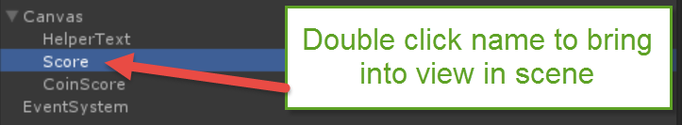
2. Next change the textbox size by clicking on the 2D tool icon (1) and then resizing the textbox (2).

* NOTE - UI elements are setup in a different area of the screen than what your scene is in.It seems weird, but there are technical reasons for this. After you work with this text box, I’d recommend just double clicking VampKid or some other game object to bring them back into view.

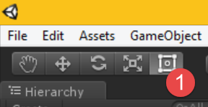

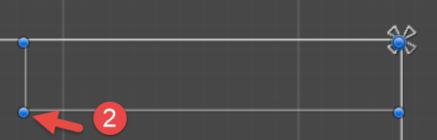

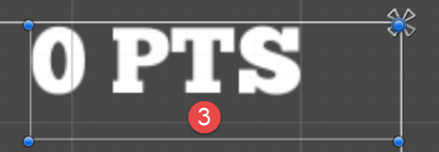

Create another textbox to go in the upper left hand corner for coin pickup points

1. Select the GameObject/UI/Text menu to create a new textbox
2. Rename it to **CoinScore**
3. Dock it to the top left by clicking the anchor grid as shown below (1), then holding shift-alt and the top left corner



1. Set the values as follows

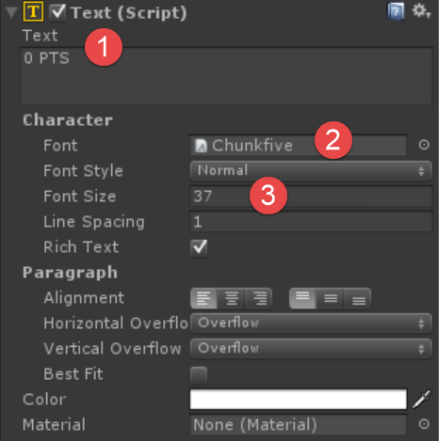

As an additional exercise, I added the coin image to the top left. If you want to do this, the coin score and coin image will need to be anchored to the top left and then moved to the right slightly

1. Go to the menu GameObject/UI/Image to create a UI image game object (meant to be used with the overlayed UI system in Unity, which is separate than the sprites we’ve dragged into our scene)
2. Dock it to the top left by clicking the anchor grid (to the left of #3 in the below image) as we have done previously, hold shift/alt and click the top left in the grid to dock it there.
3. Set the Coin properties
   1. Check off Preserve Aspect
   2. Select the coin01 image using the circle selector or drag /Assets/Images/coin/coin01.png onto the region noted bby #2 in the image below to assign it to the Source Image
   3. Set the width/height to 52,46
   4. Rename the object to Coin

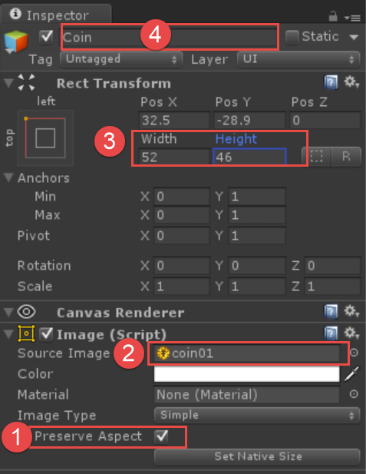

* 1. Click the 2D tool on the toolbar and move both the Score game object and Coin game object over a bit as they are overlapping and jammed into the upper left hand corner.

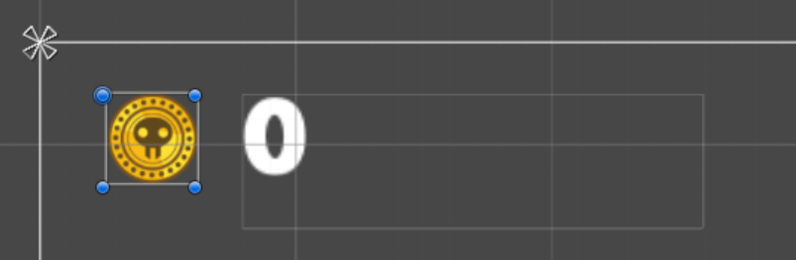

* 1. Finally, we need to change the behavior on the Canvas Scaler component that is already on the Canvas game object. It is there by default but we need to configure it to resize everything within our UI when the resolution changes. Select the Canvas game object
  2. Set the Canvas Scaler component values as follows for UI Scale Mode, Reference Resolution, and Screen Match Mode to Scale with Screen Size, 800, 400, and Expand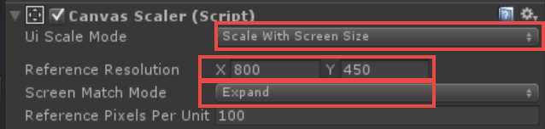
* TIP – We use the above values to ensure our fonts and images scale with the various aspect rations our game can run on. With Windows 10, users can resize the game windows to with whatever aspect they’d like to see your game at.

1. We need a variable in our GameController class that can hold a reference to the Text component created above that will show a message to the user. In /Scripts/GameController.cs, find //LevelMessageText here and replace it with the following code.

* NOTE - The other text variables have already been setup in this file for you, we are setting just this one up to show the process as PointsText, CoinScoreText are already setup for you.

C#

* 1. //The name of the next scene file to load when we reach the portal.

//This is without the .scene extension. For ex. just Level2

public Text LevelMessageText;

1. In the Start() method in GameController.cs, add the following line in place of //LevelMessageText Error check to give some decent error handling in case the user forgets to setup the reference between the variable and the Text component in the editor.

* NOTE - The other text component error messages are already there. This is just to show you a process for adding a ‘sanity check’ for a component whose reference should be set in the editor via drag/drop.

C#

if (LevelMessageText == null)

{

Debug.LogError("LevelMessageText hasn't been set to a Text element in your scene yet. Ensure you drag/drop from the editor onto the Level Message Text element on the GameController script component");

}

* TIP - If you are using Visual Studio as your code editor in Unity, you can press control-k control-d to format your code automatically and clean it up

1. Add the code to display messages on the screen in /Scripts/GameController.cs in place of //ShowLevelMessage here (this is towards bottom of the code file) This will simply set the textbox visible and show the text on the screen when we call this method. The text will then fade out after 5 seconds.

C#

* 1. public void ShowLevelMessage(string message)
  2. {
  3. LevelMessageText.text = message;
  4. //ensure we've enabled this textbox since it may be
  5. //disabled in the scene view so as to not obstruct the view
  6. LevelMessageText.transform.gameObject.SetActive(true);
  7. //Make the text visible
  8. var color = LevelMessageText.color;
  9. color.a = 1;
  10. LevelMessageText.color = color;
  11. //Start fading it out
  12. LevelMessageText.CrossFadeAlpha(0, 5f, false);
  13. }

1. In /Scripts/PortalController.cs let’s use our new capability to show a message on the screen. Replace //Show helper message with the code below that will be displayed to the user when they try to enter the portal but haven’t yet found the key.
   * 1. C#
2. _gameController.ShowLevelMessage("Find the key to unlock the portal!");
   1. **BUILD NOTE:** At this time, your project should play without errors although the functionality is incomplete. Make sure you’ve saved your Visual Studio changes and Unity changes. You can run to the portal but it won’t open.
3. Save your changes in Visual Studio and Unity and run your game. The functionality is incomplete – you can run to the portal but it won’t yet open. Let’s tackle that next.
4. Add the key to unlock the portal. This is a simple prefab already created with just an image and a script. Expand /Prefabs/ and take crypt_key and drag and drop it into your scene, ideally in a place surrounded by zombie that is difficult to get to. Once you collect this key, the portal doors should open.

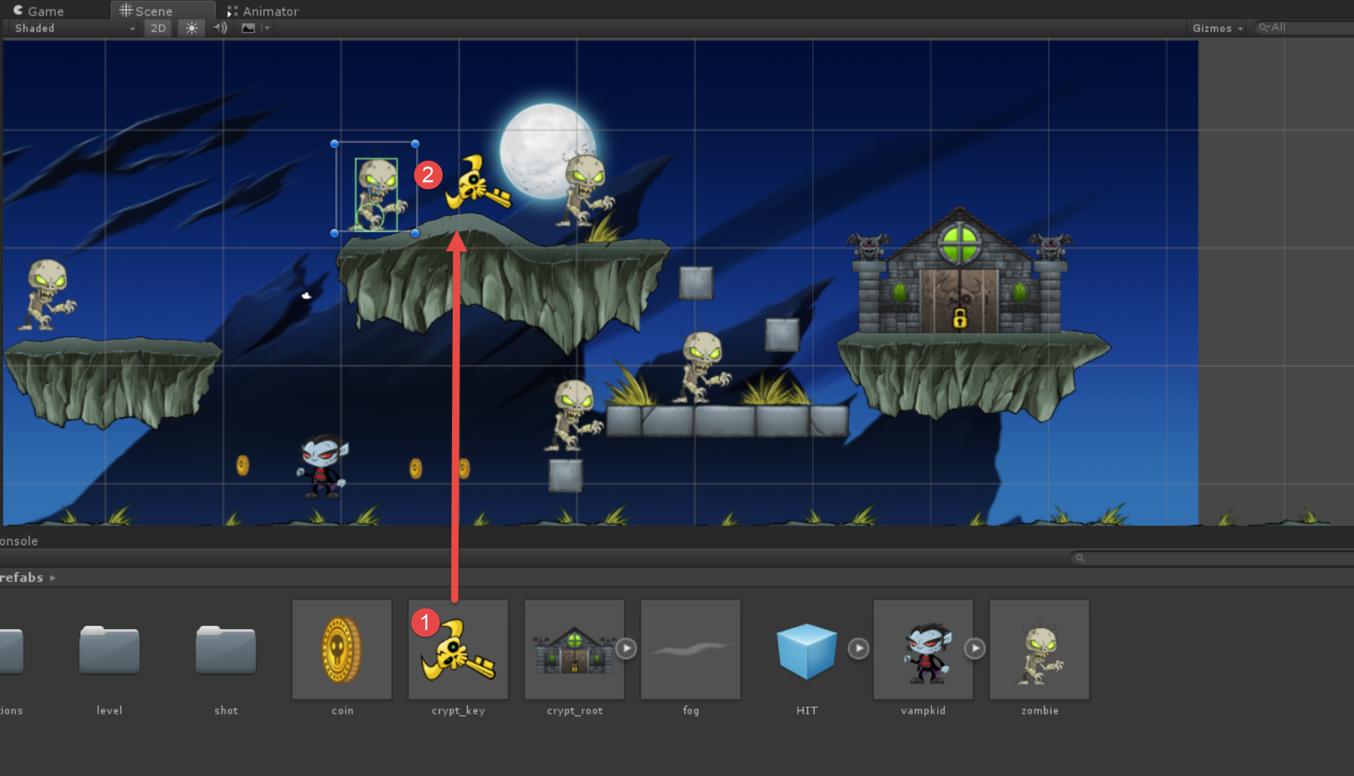

1. Next setup the GameController game object with the references to our textboxes on the screen.
   1. Click the GameController game object in the inspector to select it and note all the missing references in the Game Controller script for the text components as shown below

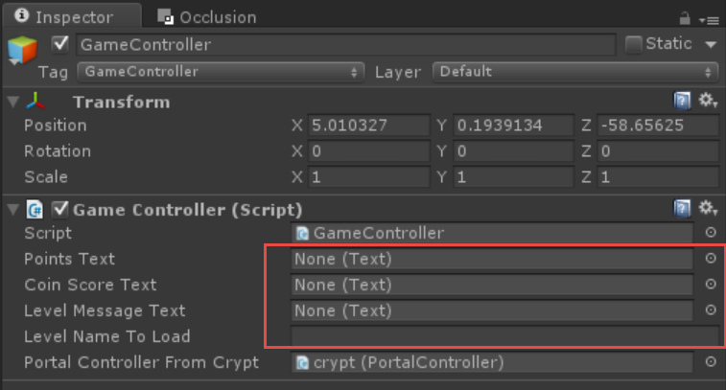

* 1. We need to fix these missing references. You can either drag/drop from within the inspector or click the circle selectors and select each text component so our GameController now looks like the following.

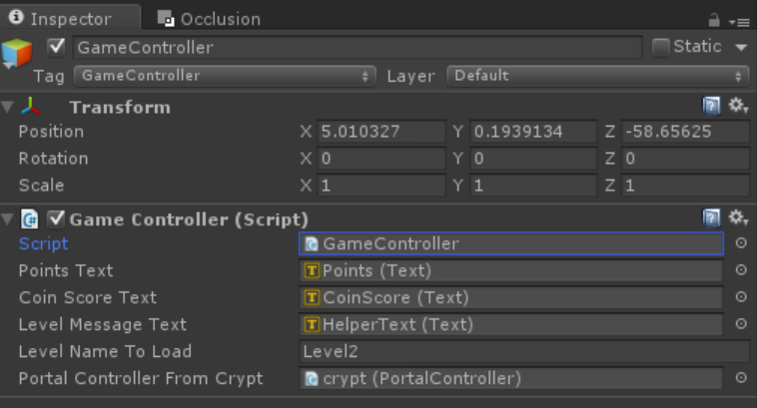

### Task 7 – Adding the zombies and player detection/elimination

Now we will add some enemy characters to the scene. Who doesn’t love a good zombie?

1. The Zombie is a game object that plays an animation. As of now, it’s pretty basic. The Zombie can get hit by the player’s attack (once we implement that functionality) and die, that’s about it at this point. Drag a Zombie from /Prefabs/zombie repeatedly into the scene to place them at various locations.
   1. As a reminder, you’ll usually want to use the 2D tool for moving sprites, although you can surely use the move tool on the toolbar. I find the 2D tool easier to work with sprites.

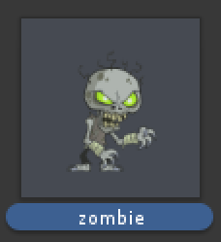 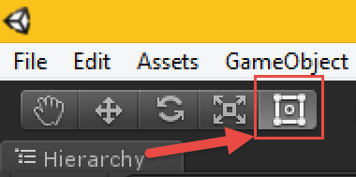

1. Make sure the Zombies are on top of the platforms. Colliders must not be touching when the game starts or the objects will pass right through each other. Note the green box and circle- those are the colliders used to tell the physics engine what area to detect collisions on.

* Tip - Ensure the circle collider is visible above the ground, or the zombie will fall right through it when the game starts.

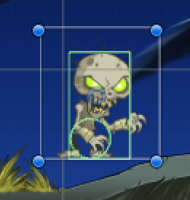

1. The zombie needs to get ‘hit’ by the projectile. The projectile has a rigidbody and a collider, which means it can collide with the trigger on the Zombie. When this happens Unity will look for an OnTriggerEnter2D() method on the Zombie. Let’s add that. Replace //OnTriggerEnter here (towards the end of the file) in the /Scripts/ZombieController.cs with the following code
   * 1. C#
     2. //Detect when the projectile hits this zombie
     3. void OnTriggerEnter2D(Collider2D collision)
     4. {
     5. //check the tag of the game object we collided with
     6. if (collision.gameObject.tag == "rocket")
     7. {
     8. _gameController.IncrementPoints(10);
     9. //Destroy the projectile
     10. Destroy(collision.gameObject);
     12. //Play the animation and reduce life of zombie
     13. GotHit();
     14. }

}

1. Let’s make the zombie wait a bit before moving (although we still need to add that moving code). In the Start() method in /Scripts/ZombieController.cs go ahead and replace //StartCoroutine here with the following code. This will start a separate task and return back to the Start() method right away. Save your code changes (control-s)

Coroutines in Unity are a way to spawn off a separate task (not a separate thread) and are typically the defacto method if you want to run a task you need to do any sort of time delay on, such as we’ll do below when we wait a few seconds.

* + 1. C#
    2. StartCoroutine(ActivateMe());

1. Now we need towrite the code to wait for a few seconds, and then set a Boolean value to true signaling our zombie can look for the main player.Replace //IEnumerator ActivateMe here in ZombieController.cs with the following method.
   * 1. C#
     2. IEnumerator ActivateMe()
     3. {
     4. //Zombies can't look for the main player for a min of three seconds
     5. yield return new WaitForSeconds(Random.Range(3, 7));
     6. //Set a flag that we’re all ready to go and seek the main player
     7. _isReadyToMove = true;
     8. }
2. Lastly, we need to add code to have the zombies look for the main player. For this, we RayCast, a technique that conceptually shoots an invisible arrow in a direction and reports back any objects it hits that have a collider/trigger on it. Every FixedUpdate frame we look for the player. If we find the player, we set the zombie’s rigidbody velocity to move towards the player. Once we no longer spot the player, we stop walking after two seconds. This prevent the zombies from immediately stopping every time the player jumps.

**A word on FixedUpdate():** Why use FixedUpdate() and not just Update()? Physics movements should typically be done in FixedUpdate() as this is tied to the timing of the physics engine which is different than the screen updates, which are tied to Update(). If you move objects in the Update() method, it can result in jittery movements so as a general rule, its best to do this in FixedUpdate().

Replace //FixedUpdate here at the end of /Scripts/ZombieController.cs with the following code

* + 1. C#
    2. void FixedUpdate()
    3. {
    4. bool foundPlayer = false;
    5. //I know, are zombies _really_ dead?
    6. if (_isDead) return;
    7. //Don't start moving until we've signaled to ourselves its time to go!
    8. if (!_isReadyToMove) return;
    9. //Check for the main player. We are using a layer mask to ONLY look
    10. //for objects assigned to layer 8 (the Player Layer) that was custom
    11. //defined in the Layers dropdown in Unity. You can see an example of
    12. //this here: http://docs.unity3d.com/Manual/Layers.html
    13. //This is a bit mask saying layer 8 is set ex a byte has 8 values
    14. //00000000 and 1<<8 becomes 10000000.
    15. var hitLeft = Physics2D.RaycastAll(transform.position, Vector2.left, Mathf.Infinity, (1 << 8));
    16. if (CheckForPlayerHit(hitLeft))
    17. {
    18. //A player was found to the left of us
    19. //Flip zombie to look to the left
    20. if (transform.localScale.x != -1f)
    21. {
    22. var scale = transform.localScale;
    23. scale.x = -1;
    24. transform.localScale = scale;
    25. }
    26. //The left is a vector with values -1,0,0. Multiply by speed

//and a smoothing value Time.deltaTime so no matter the framerate

//we'll move at 75 units a second

* + 2. //Also, store the last velocity as we'll keep the zombie
    3. //moving for two seconds even when we don't see the player
    4. //Also don't change the Y velocity (don't override whatever
    5. //falling may be happening if we set the y velocity to 0
    6. //the zombie won't fall correctly as we'll be fighting physi cs)
    7. _lastVelocity = transform.TransformDirection(-1 * Time.deltaTime * 75, 0, 0);
    8. _rigidBody.velocity = _lastVelocity;
    9. foundPlayer = true;
    10. }
    11. else
    12. {
    13. //Didn't find on the left, now check the right
    14. var hitRight = Physics2D.RaycastAll(transform.position, Vector2.right, Mathf.Infinity, (1 << 8));
    15. if (CheckForPlayerHit(hitRight))
    16. {
    17. //Found player to the right
    18. //Flip towards player if necessary
    19. if (transform.localScale.x != 1f)
    20. {
    21. var scale = transform.localScale;
    22. scale.x = 1;
    23. transform.localScale = scale;
    24. }
    25. //Move the zombie
    26. _lastVelocity = transform.TransformDirection(1 * Time.deltaTime * 75, 0, 0);
    27. _rigidBody.velocity = _lastVelocity;
    28. foundPlayer = true;
    29. }
    30. }
    31. if (foundPlayer)
    32. {
    33. _playerSpottedTime = DateTime.Now;
    34. }
    35. else
    36. {
    37. //We didn't find the player. If it's been < 2 seconds
    38. //since we've seen the player, pretend we still see him and move.
    39. if (_playerSpottedTime != DateTime.MinValue &&
    40. DateTime.Now.Subtract(_playerSpottedTime).TotalSeconds < 2)
    41. {
    42. foundPlayer = true;
    43. //Just keep moving in the direction we were previously moving in.
    44. _rigidBody.velocity = _lastVelocity;
    45. }
    46. }
    47. _animator.SetBool("Walk", foundPlayer);
    48. }
    49. //See if we've hit the player with any of the Raycast hit info
    50. private bool CheckForPlayerHit(RaycastHit2D[] hitLeft)
    51. {
    52. if (hitLeft == null) return false;
    53. if (hitLeft.Length == -1) return false;
    54. for (int i = 0; i < hitLeft.Length; i++)
    55. {
    56. var item = hitLeft[i];
    57. if (item.transform.gameObject.tag == "Player") return true;
    58. }
    59. return false;
    60. }

1. Ensure you have saved your changes both in Unity and Visual Studio and play the game.
2. Play the game - at this point you should be able to play the game, shoot and kill zombies (who move towards you if they are within a straight left to right line of sight from you). If you think they die to easily, their health can be adjusted by the Health property on a zombie. **Change it on the /Prefabs/Zombie to ensure the change affects all zombies** 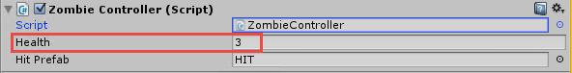
3. Add code to the GameController so we can restart the level when the player dies.

Open /Scripts/Gamecontroller.cs and add this code in place of //PlayerDied goes here . This code will show a message on the screen via an existing custom function called ShowLevelMessage that displays centered text.

Note the Application.LoadLevel(Application.loadedLevel) below, this will reload the current level. If you want to load a different level, simply pass in the scene name ala Application.LoadLevel("Level2")

* **TECH TIP -** You’ll notice the different look of StartCoroutine() and IEnumerator ReloadLevel(). A coroutine is a different task (code method) that can be spawned off. This is not the same as spawning off another thread though. We typically let Unity handle threads internally, and use the coroutine system to manage our separate tasks. All Coroutine methods start with IEnumerator MethodName(). In these methods you can wait for a single frame before continuing (they are processed by default when Update() calls run) or even sleep for a few seconds – which works great for random spawning as well. We cannot ‘sleep’ or pause inside of an Update() method, so coroutines work great for these types of tasks. Coroutines by default are processed during each frame (ie Update) and a yield return null; for ex. means ‘wait for one frame and then resume’

C#

* 1. public void PlayerDied()
  2. {
  3. ShowLevelMessage("You died! Restarting....");
  4. StartCoroutine(ReloadLevel());
  5. }
  6. /// <summary>
  7. /// Coroutines (those with IEnumerator) must be started via StartCoroutine()
  8. /// We can do things like pause for a time in them.

/// In this case, pause for two seconds and reload the current level

* 1. /// </summary>
  2. /// <returns></returns>
  3. IEnumerator ReloadLevel()
  4. {
  5. //wait for two seconds
  6. yield return new WaitForSeconds(2);
  7. Application.LoadLevel(Application.loadedLevel);

}

1. Modify the VampKids code to detect a hit with the zombie.

Double click on the /Scripts/VampController.cs file to edit the code. Inside this file class replace //OnTriggerEnter code here with the code below. This could really go anywhere in the file – position isn’t important as long as its inside the class definition and not inside of another method, but for those new to coding lets have a consistent place to put it– plus it helps when we want to compare this code to the completed versions code.

* + 1. C#
    3. void OnTriggerEnter2D(Collider2D collision)
    4. {
    5. if (collision.gameObject.tag == "zombie")
    6. {
    7. //What to do when we hit the zombie? We die!
    8. //Disable our physics
    9. _rigidBody.isKinematic = true;
    10. //Disable the vamp image
    11. GetComponent<SpriteRenderer>().enabled = false;
    12. //Enable bat particles here
    13. //He's dead Jim.
    14. _dead = true;
    15. //While we're at it, let's kill the zombie we just hit :)
    16. //Fixes the silly issue of having the zombies have a
    17. //rigidbody and a collider and they get pushed when we hit them.
    18. //We can get the zombie from collision.gameObject, then we just need its ZombieController.
    19. collision.gameObject.GetComponent<ZombieController>().KillZombie();
    20. //Tell the game controller we are all gone, let it decide what to do next.
    21. _gameController.PlayerDied();
    22. }
    23. }

#### Why are there two colliders on the VampKid?

Let’s explore the VampKid’s colliders. He has two of them, neither one is a trigger. They are full colliders – regions that Unity will perform physics calculations and interactions on. The VampKid already has a circle collider 2d on it and the box collider 2d which will cause Unity to call the OnCollisionEnter() method when either one is collided with. However, our VampKid code contains both OnCollisionEnter2D and OnTriggerEnter2D() code. Why?

OnCollisionEnter2d –The circle collider gives a nice movement across a surface, doesn't catch as many edges as a box collider would – think of a circle moving across an uneven surface vs a box shape moving across an uneven ssurface. The CircleCollider2D on the VampKid uses the circle collider along with the rigidbody to move the character. This just ‘happens’ because it’s a collider and not a trigger (a trigger doesn’t affect the rigidbody). This circle is pretty small because if it is scaled out larger it makes for too big of a collision region on the sides of the VampKid and he’ll get caught on things. The circle collider is small, and then a box collider controls the rest of the collision region as shown in **Figure 8** belowto ensure that we can hit the vampire outside of just the circle area.

OnTriggerEnter2D on the VampKid seems a bit misleading. The trigger is actually a component (collider) on the Zombie, not on the VampKid. Unity will call OnTriggerEnter2D() on **both game objects** (if the OnTriggerEnter2D is implemented on either object in code) upon the collision(trigger) happening, so I chose to detect the collision/trigger with the zombie in OnTriggerEnter2D on the **player** instead of the zombie. Colliding with a zombie is a game ending experience for the player so it seemed to make more sense to include the code on the player. Either the VampKid or the Zombie would have worked though to have OnTriggerEnter2D.

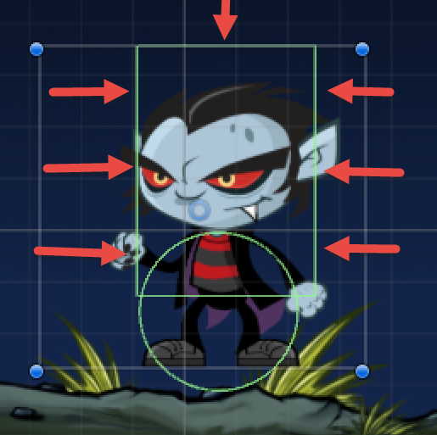 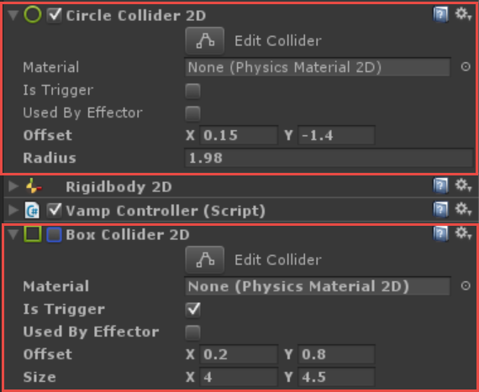

Figure 8 Box collider 2D and Circle collider 2D providing collision detection areas

1. Next, change the player to launch particle effects when it dies. Replace //Enable bat particles here in OnTriggerEnter2D() with the following code to enable the particle system to play upon player death as shown in **Figure 9**
   1. How does this work? The VampKid prefab has a child game object called bat_burst. This child game object has been assigned (in the editor) when the prefab was creatd to the _batBurst variable. Expand the VampKid object and note the disabled particle effect. There are three effects, one for the bats, one for the purple flash, and one for the purple dots.

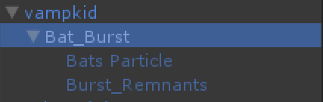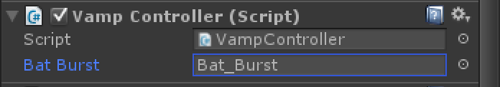

* + 1. C#
    2. //Enable bat particles here
    3. _batBurst.SetActive(true);
* NOTE – First, a word on particle systems. Particle systems can take images (even basic ones like circles or animated ones like bats) and control their size, shape, color, rotation, and other parameters over their lifetime giving effects like rain, explosions, etc. We use animated bats and a color explosion when the VampKid dies to give a really cool effect.

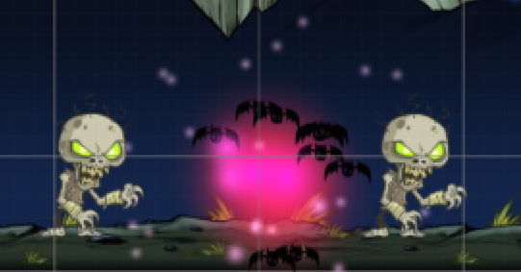

1. Save your changes in Unity and Visual Studio (control-s is still your friend)
2. Play your game. Run the VampKid into a Zombie and he should explode into a series of bats as shown above
3. Get out of play mode.
4. At this point, the game does not restart upon collision. Let’s go ahead and open /Scripts/VampController.cs so we can change its behavior when the collision with the zombie occurs.
5. Save your code changes, run the game again in Unity and test that the level restarts when you run into a zombie.

### Task 8 – Building for Windows

Now that we have created our game we need to build for Windows. Unity will export a Visual Studio solution, but we’ll need to tell Unity what to include in this build. As it stands now, our GameController will try to load Level2 when you get to the portal. It tries to load whatever level we have specified on the Game Controller script component on the GameController game object as shown below.

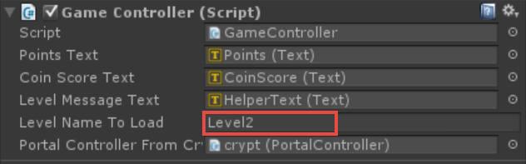

1. Level2 doesn’t yet exist. Go into your /Assets/Scenes folder, highlight Level1 and press Control-D to duplicate it. Level2 should appear as shown below - which gives us a base all setup to customize for our next level. Feel free to open it and customize this level and save it.

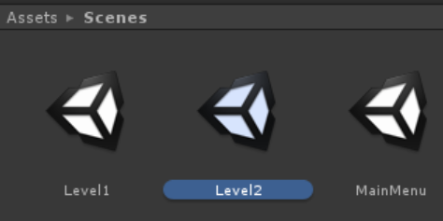

1. Finally, we need to configure the scenes to be part of the build. We cannot load a scene up unless it is part of our build settings. Go to File/Build Settings and then drag each of your scenes you want in your final build located in /Assets/Scenes into the top of the window as shown below. Ensure MainMenu.unity is listed first as then this will be the default scene to open. Since this is the title screen, that is desired.

* NOTE – The code on the GameController.cs already contains the API call to load the next level, and that is simply Application.LoadLevel(“YourSceneName”)

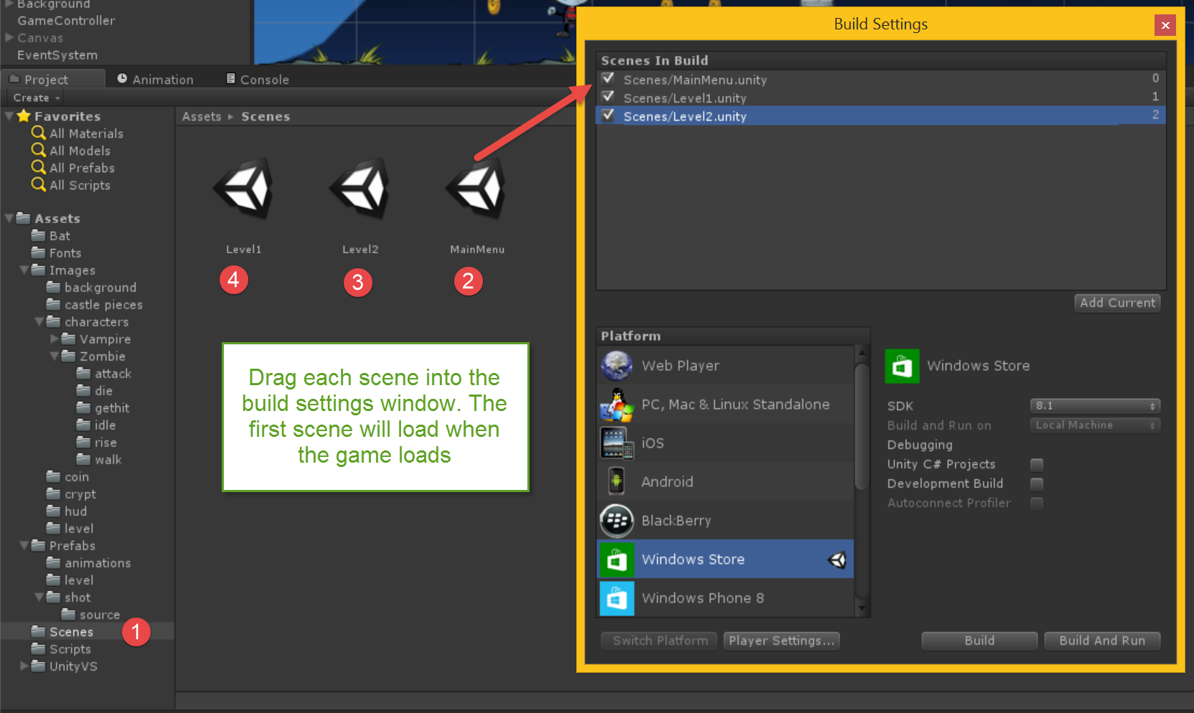

1. Bring up the build settings from File/Build Settings.
2. Select Windows Store and then UWP from the dropdown or Windows 8.1 depending on the platform you are building for. Once selected, click the Switch Platform button to enable this as the default build platform.

* NOTE - The process is nearly the same between 8.1 Universal apps and Windows 10 Universal Windows Platform(UWP)

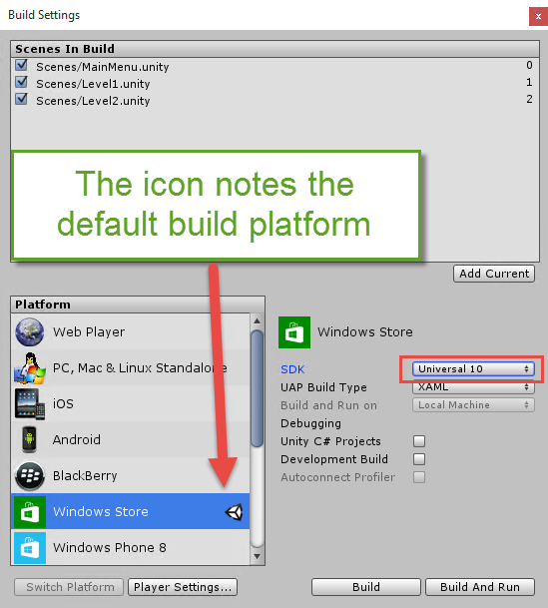

1. Click on the Player Settings button to change the company name, app name, etc as shown below.

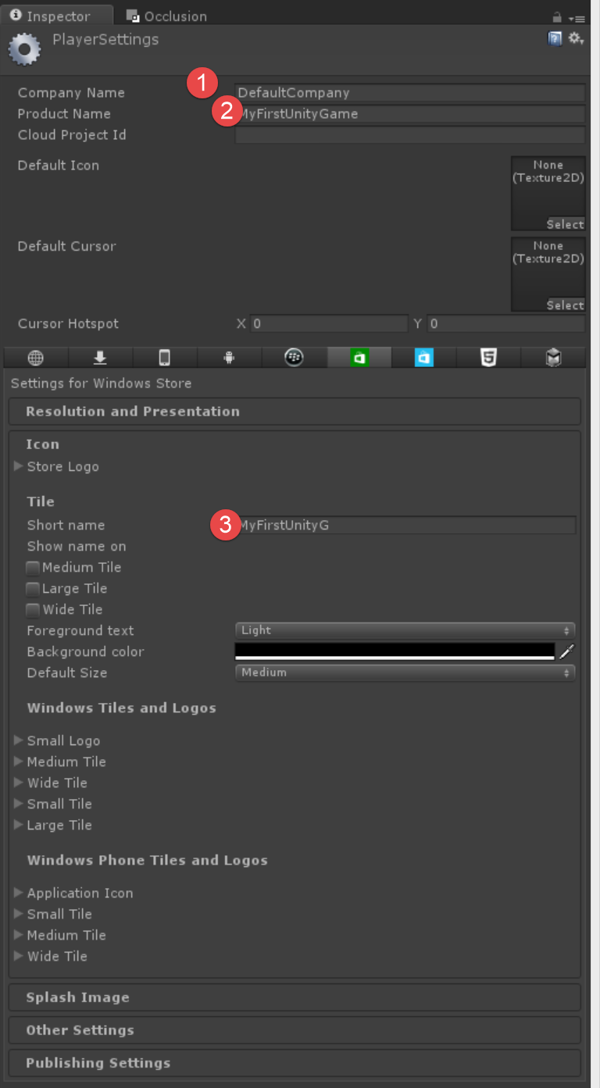

1. Next, you should set all of your icons. Windows can run on many different device types and sizes and as such can support many different scale icons. One is for showing the app in the Windows Store, one is a splash screen, one is shown on the user’s system, etc. Unity sets a generic icon for five of these on each platform, but they don’t specify in the Editor which ones.

* NOTE – What follows may seem a bit daunting with all the images. Don’t worry, this step takes just a couple minutes.

1. First – if you are on the 4.x FREE version or 5.x Personal edition of Unity, the splash screen will be disabled. This is part of the license with Unity, their splash screen will be displayed and you cannot override that from the Editor.

* TECH TIP - (Skip if you just want to get through this fast) All of these icons here are actually set in the package.appxmanifest file in your Visual Studio Solution Unity builds for you. If you forget to set them in Unity, it is usually easiest to just delete your generated build folder and recreate it from Unity (or add it to the package.appxmanifest file if you’ve made any custom changes to that VS solution). Unity will not overwrite your basic solution files once it has generated it, it will only overwrite the /data folder in your solution’s game project (a solution in Visual Studio actually contains one or more projects) on repeat builds which contains your in-game experience like scenes, game objects, etc – not your application icons.

1. Create set some icons - Visit this: <http://wat-docs.azurewebsites.net/Tools> and upload an image that will get turned into a splash screen and icons. Choose a background color. This will generate all of your icons (actually way more than we need, you will select out only the ones you need from the resulting zip file as you will see in step 10). Choose one of these options on the web page to download your resulting images.



1. **Windows Phone 8.1 builds ONLY**- Set these in Unity to overwrite what Unity will set as a default. You don’t want your game going to the store with just a Unity default icon instead of your killer icon ☺ Note that all of these icons are the Scale 240 version, ie their file names in the downloaded file all end with -240.png

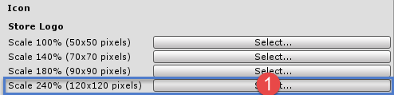

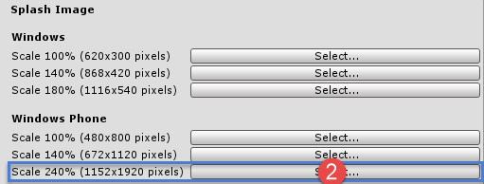

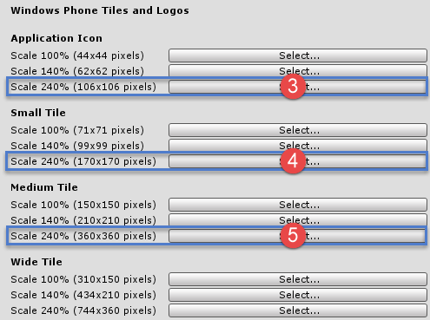

Select the following images from the zip file as shown below. Notice the number int he images above and below so you see how they match up. You just need the highlighted ones below to overwrite Unity’s default images they have already provided. Copy them out and put them in a folder in your Unity project.

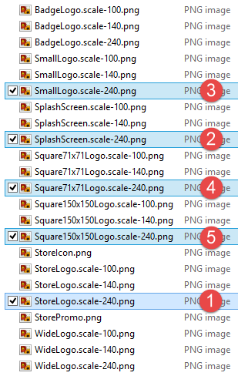

* TIP - if you just want to delete the rest in the zip to make it cleaner, you need to end up with just these files (the same images as shown above)

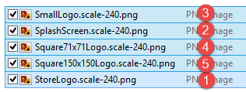

1. **Windows Store build only**- These are all scale 100, ie their file names all end with -100.png in the zip file

50x50 Store Logo

150x150 Square Logo

30x30 Store Logo

620x300 Splash Screen

310x150 Wide Logo

* NOTE – The Wide logo is useful when the user pins your app to the start screen. This is useful for dynamic updates to the icon or just extra info on the icon. If not using this, you can submit your app without it, it is not required but note Unity does provide a default one that will be displayed, so you probably want to include your own. Note how the game Cut the Rope makes use of various tile sizes in case users want to customize their start screen

 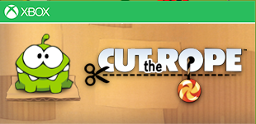

1. In the zip file you generated your images in, you’ll need only these files. See below where we set them in Unity

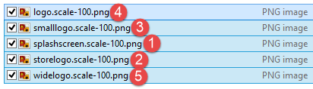

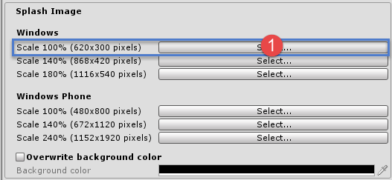

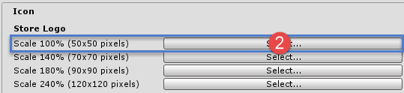

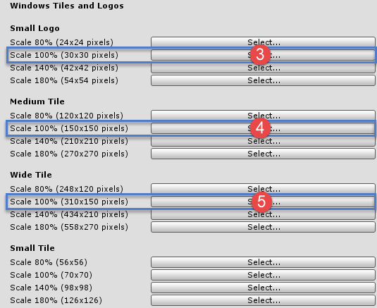

1. Now it is time to build your project from Unity. Click the Build button in the Build Settings dialog.Create a new folder called Builds and a folder called Windows Store underneath that as shown below
2. Select that folder in the build dialog 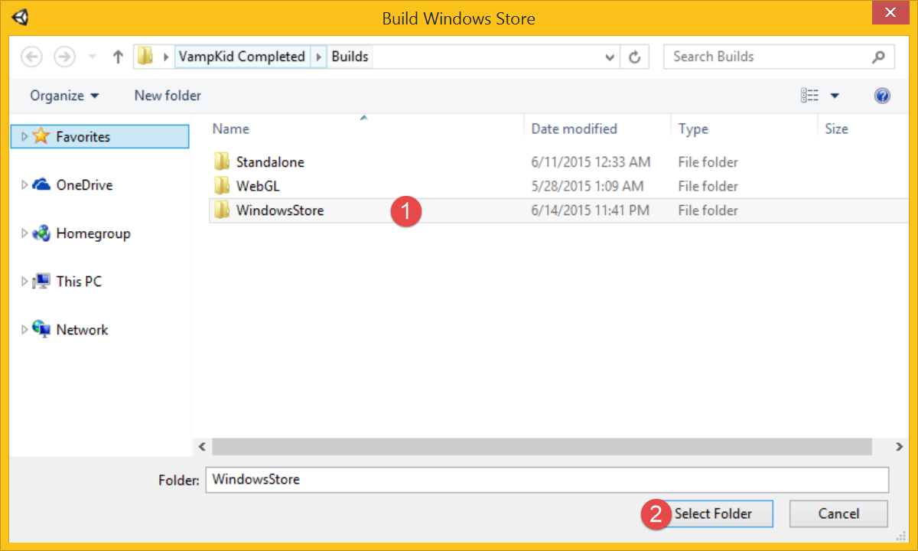
3. Unity will build your project. If there are any issues, the process will abort early sometimes with a ‘ding’ sound, but check the very bottom of Unity’s screen for an error. The build process may take a couple minutes, If it stops after a few seconds there’s likely an error you need to look for.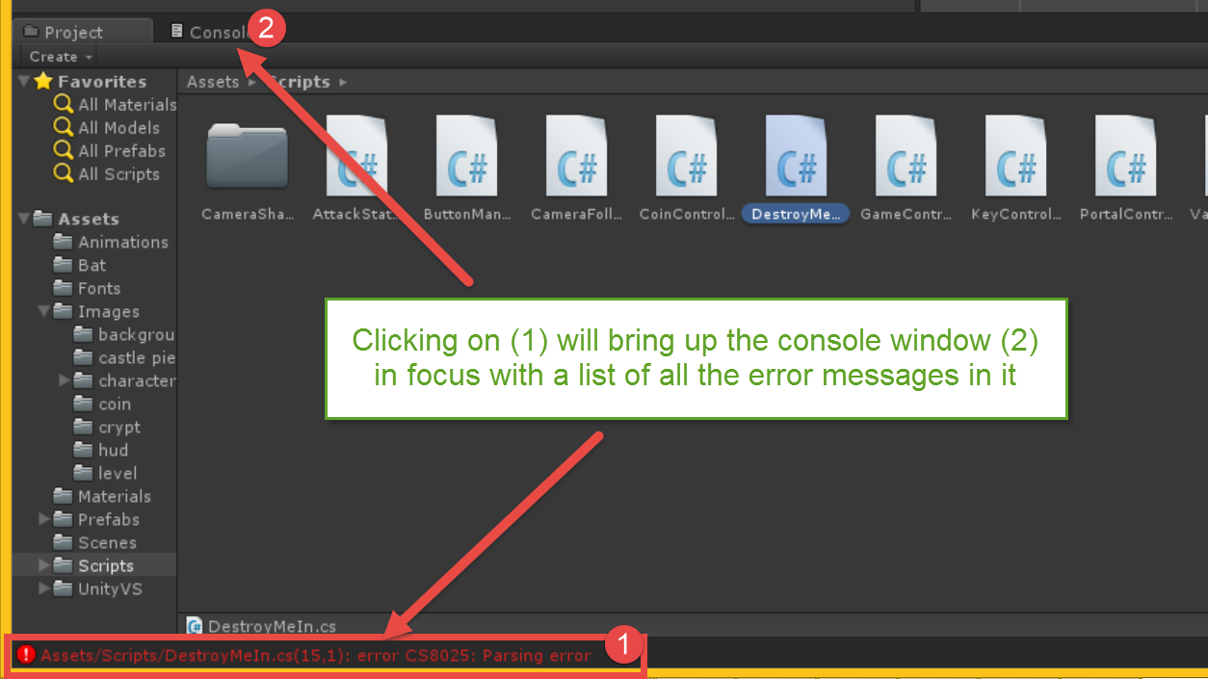
4. If successful, Unity should open a resulting explorer folder in Windows, but it may be in the background and not have the focus. Look on your taskbar for an Explorer window and open it if it did not appear **and** there was a successful build.
5. Double click on the generated Visual Studio solution file. These files end in .sln. 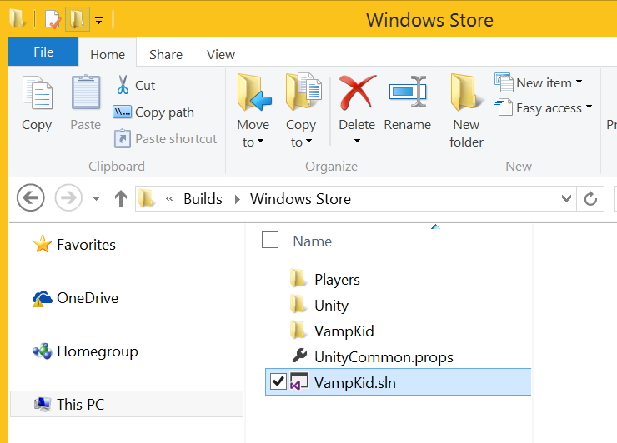
6. When Visual Studio opens, change the following from ARM to x86 and Debug to Master as shown below 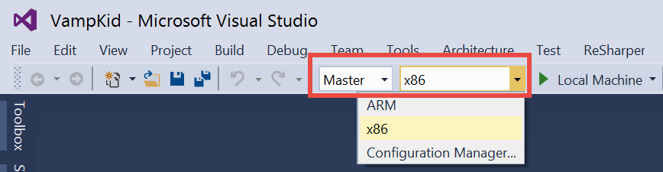

* NOTE – The default build Unity creates is for ARM processer architecture devices. Most Windows Store devices are x86 based processor architecture so you need to tell Visual Studio to use x86. Also note that Debug builds generate slower games since they aren’t optimized. You’ll want to change this to Master to test the performance on your system.

1. Click the Play button on the toolbar to compile, deploy the game on your local machine, and run it. When done, mouse your mouse to the upper right hand corner to show the title bar and X the window closed or use alt-f4 (the standard close-task hotkey in windows)

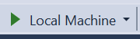

* WINDOWS PHONE - If you have a Windows Phone, simply change the drop down from Local Machine to Device and it will deploy to your device assuming you have developer registered your phone with the Windows Phone Developer Registration tool.

Congrats! You have now built a complete and fully functional Windows 10 Unity Game!

Summary

* 1. This lab introduced you to developing a game as a Windows 10 UWP application using the Unity Game Engine. In the course of this lab you created a Windows 10 UAP application project, loaded the game’s resources, took care of the input, updated the game state, and added game specific logic.
  2. By completing this hands-on lab, you also became familiar with the tools required to create and test a Unity game project for Windows. In this lab, you created a new Unity application for Windows using Visual Studio 2015 and the Visual Studio Tools for Unity, and then created the application logic and the layout of the user interface.